NATIONAL RESEARCH UNIVERSITY

HIGHER SCHOOL OF ECONOMICS

Graduate School of Business

Goldobina Olga

Eremeko Ivan

Maslennikov Vladislav

Shabanova Diana

**DATA INFRASTRUCTURE FOR MUSIC STREAMING SERVICE**

SEMESTER PROJECT ON THE SUBJECT

“Advanced Data Management”

Field of study: Business Informatics

Degree programme: Business Analytics and Big Data Systems

|  |  |
| --- | --- |
| Moscow 2023 | Supervisor  Panfilov Petr Borisovich |

**Table of content**

Introduction 2

Market Overview 5

Business model 9

Data modeling 13

Database formation 18

Data sources and data creation 25

Development of useful queries for the database 26

Creating stored procedures 35

Creating Triggers 37

Creating Views 37

Creating Functions 38

CRUD matrix 40

Master data standards 42

BI development 44

Bibliography 47

# 

# Introduction

The project of creating a data infrastructure for a music streaming service aims to establish a robust and scalable system to support the storage, processing, and analysis of data related to the service's operations. The data infrastructure will facilitate efficient management of music content, user interactions, and business processes. This introduction provides an overview of the project structure, highlighting key components and objectives.

Market Overview:

1. The project begins with a comprehensive market overview, which entails analyzing the current landscape of the music streaming industry. This includes understanding market trends, competitor analysis, user demographics, and consumer behavior. The market overview helps identify opportunities, challenges, and potential areas for differentiation within the industry.

Business Model Description:

1. The business model of the chosen company or organization operating the music streaming service is described in detail. This includes outlining the value proposition, revenue streams, content acquisition and licensing strategies, technology infrastructure, user engagement and retention initiatives, and data analytics and advertising approaches. Understanding the business model is crucial for designing an effective data infrastructure that aligns with the company's goals and objectives. Several UML diagrams were also developed to support the business model.

Data Model Development:

1. The data model development consists of creating a conceptual, logical, and physical data model specific to the music streaming service. The conceptual data model represents the high-level entities and relationships within the domain. The logical data model defines the detailed structure and attributes of the data entities, while the physical data model specifies the implementation details and database schema.

Database Creation and Data Population:

1. Based on the defined data model, a database is created to store the music streaming service's data. This involves selecting an appropriate database management system (DBMS) and setting up the necessary tables, columns, and indexes. The database is then populated with either real or synthetic data to simulate realistic scenarios and ensure the infrastructure's readiness for production use.

Role and Data Asset Management:

1. A list of roles involved in accessing and managing the data assets is established. Each role's permissions and responsibilities are defined in terms of create, read, update, and delete (CRUD) operations. This role to asset matrix ensures proper access control and data governance, safeguarding the integrity and security of the data assets.

Master-Data Standards:

1. The project involves defining and documenting the master-data standards for critical data entities such as artists, albums, songs, user profiles, and playlists. These standards ensure consistency, accuracy, and uniformity across the music streaming service, enabling seamless integration and reliable data analysis.

Multidimensional Model for Business Intelligence (BI):

1. A multidimensional model is developed to support business intelligence and reporting needs. This involves designing a data schema optimized for analytical queries, defining dimensions (e.g., time, geography, genre) and measures (e.g., play counts, user engagement metrics), and establishing hierarchies and relationships. The BI solution enables in-depth analysis, trend identification, and data-driven decision-making.

Data Sources for Conceptual Data Model:

1. A comprehensive list of data sources is compiled to support the conceptual data model. This includes identifying internal and external data sources, APIs, streaming data feeds, and third-party integrations. Understanding the data sources helps ensure that all relevant data is captured and integrated into the data infrastructure for comprehensive analysis and insights.

By following this project structure, the data infrastructure for the music streaming service will be designed, implemented, and optimized to support the company's operations, enable data-driven decision-making, and enhance the user experience.

# Market Overview

A music streaming service is an online platform that allows users to listen to music on-demand over the internet. It provides a vast catalog of songs and albums from various artists, genres, and record labels, which can be accessed anytime and anywhere with an internet connection. Music streaming services have gained popularity as a convenient and affordable alternative to traditional music consumption methods, such as purchasing physical albums or downloading digital files.

The music streaming industry has experienced significant growth and transformation over the past decade, revolutionizing the way people discover, access, and consume music. A market overview of music streaming services provides insights into the current state of the industry, key trends, market size, user behavior, and competition. Here are some key points to consider in a market overview:

1. Market Size and Growth: The music streaming industry has witnessed remarkable growth, driven by the increasing popularity of digital music consumption and advancements in technology. According to industry reports, the global music streaming market was valued at over $XX billion in 202, and it is projected to continue growing at a significant compound annual growth rate (CAGR) in the coming years.
2. Shift from Physical Sales to Digital Streaming: Traditional methods of music consumption, such as physical sales of CDs and digital downloads, have been largely overshadowed by the rise of music streaming services. Streaming has become the dominant revenue source for the music industry, surpassing other formats in terms of revenue generation and market share.
3. User Demographics and Behavior: Music streaming services have gained widespread adoption among users across various demographics. Younger generations, particularly millennials and Generation Z, are heavy users of streaming platforms. Users appreciate the convenience, accessibility, and vast catalog of music available for streaming. Mobile devices, such as smartphones and tablets, play a significant role in music consumption.
4. Personalization and Recommendation Algorithms: Personalized music recommendations and curated playlists have become key differentiators for music streaming services. Advanced algorithms analyze user listening patterns, preferences, and behavior to deliver tailored recommendations, enhancing user engagement and satisfaction.
5. Licensing and Partnerships: Music streaming services rely on licensing agreements with record labels, music publishers, and artists to legally stream copyrighted music. Securing licensing deals and forming strategic partnerships with content creators and artists is crucial for a comprehensive music catalog and exclusive content offerings.
6. Monetization Models: Music streaming services generate revenue through various monetization models. Subscription-based models, where users pay a monthly or annual fee for ad-free access and premium features, are the primary revenue source. Ad-supported free tiers and partnerships with brands for sponsored content and advertising also contribute to revenue generation.
7. Innovation and Differentiation: To stay competitive, music streaming services continually innovate and differentiate themselves. They invest in features such as high-definition audio, offline listening, integration with smart devices, and original content production. Live events, podcasts, and artist collaborations are additional avenues for differentiation and attracting new users.
8. Regulatory and Legal Considerations: Music streaming services must comply with copyright laws, licensing agreements, and regional regulations specific to each market they operate in. These legal and regulatory considerations shape the business strategies and operational aspects of streaming services.
9. Emerging Technologies and Future Trends: The music streaming industry continues to evolve, with emerging technologies such as artificial intelligence, voice assistants, and smart speakers shaping the future of music consumption. Personalized user experiences, immersive audio technologies, and seamless integration with other entertainment platforms are expected to drive future growth.

Top five music streaming services in the world is:

1. Spotify: With over 350 million monthly active users and 170 million paid subscribers , Spotify is the largest music streaming service globally. It offers a vast music library, personalized playlists, and a free ad-supported tier.
2. Apple Music: Apple Music has over 72 million paid subscribers . It integrates seamlessly with Apple devices and offers a diverse music catalog, curated playlists, and exclusive releases. It also includes features like radio stations and music videos.
3. Amazon Music: Amazon Music has a large user base due to its integration with Amazon's ecosystem. It offers multiple tiers, including a paid subscription with access to millions of songs, ad-supported free streaming, and a higher-quality tier called Amazon Music HD.
4. Tencent Music Entertainment (TME): TME is a major music streaming service in China, with over 600 million active users. It operates popular platforms such as QQ Music, KuGou, and KuWo, offering a vast library of Chinese and international music.
5. YouTube Music: YouTube Music combines the extensive music library of YouTube with additional features focused on music streaming. It offers both free ad-supported and premium subscription options, with access to music videos, live performances, and user-generated content.

Top three music streaming services in Russia is:

1. Yandex Music: Yandex Music is one of the leading music streaming services in Russia. It offers a vast catalog of Russian and international music, personalized recommendations, curated playlists, and offline listening. Yandex Music also integrates with other Yandex services and has a large user base in Russia.
2. VK music: VK is a Russian music streaming service that focuses on providing high-quality audio and exclusive content. It offers lossless audio streaming and a catalog of high-definition music tracks. VK aims to cater to audiophiles and music enthusiasts who prioritize audio quality.

# Business model

Unfortunately, due to the sanctions imposed against Russia in 2022, all major music streaming services left Russia. As indicated in the previous chapter, there are popular music services in Russia. However, we decided to develop the infrastructure not for them, but for our own music streaming

The business model of a music streaming service typically revolves around providing users with access to a vast library of music content through a digital platform. Here's a description of the key components of a typical music streaming service's business model:

1. Value Proposition:
   * Access to a vast music library: Users can access a large collection of songs, albums, and playlists across various genres and artists.
   * Convenience and mobility: Users can stream music on-demand anytime, anywhere, using various devices such as smartphones, tablets, and computers.
2. Revenue Streams:
   * Subscription fees: Users can pay a monthly or annual subscription fee to access the full features of the streaming service, including ad-free listening, offline playback, and higher audio quality.
3. Content Acquisition and Licensing:
   * Licensing agreements: The service negotiates licensing deals with music labels, publishers, and artists to obtain the rights to stream their music catalog.
4. Technology Infrastructure:
   * Music streaming platform: The service operates a robust and scalable platform that can handle millions of users simultaneously, ensuring smooth streaming and reliable user experience.
5. Data Analytics and Advertising:
   * User data analysis: The service leverages user data such as playlist info, track info, user info, subscription info.

The music streaming service business model aims to provide a seamless and personalized music experience to users while generating revenue through subscriptions, advertisements, partnerships, and licensing agreements. Continuous innovation, user engagement, and building a comprehensive music catalog.

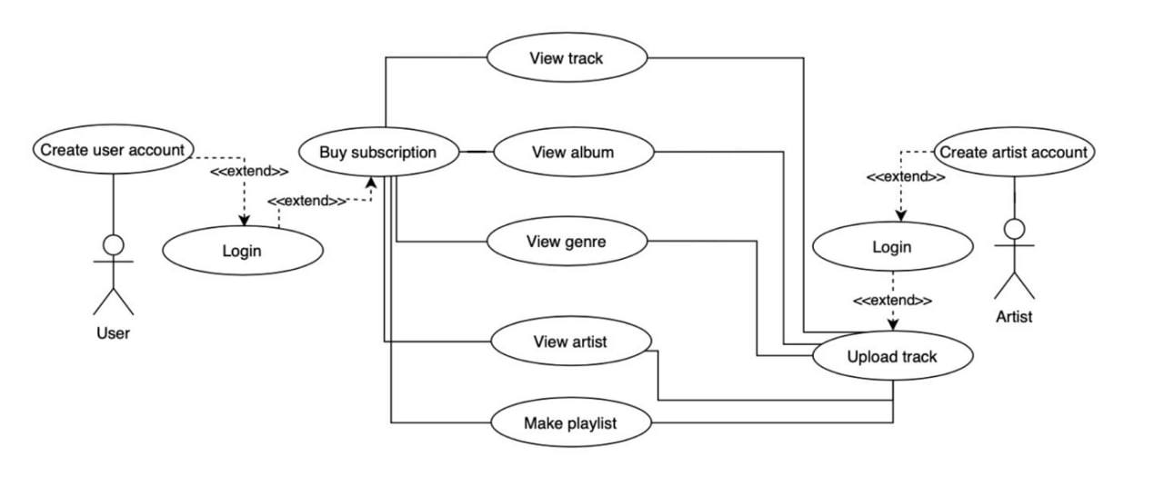

Figure 1. UML diagram

A UML activity diagram for making a playlist in a music streaming service can be represented as follows:

## 

Figure 2. UML activity diagram for making playlist

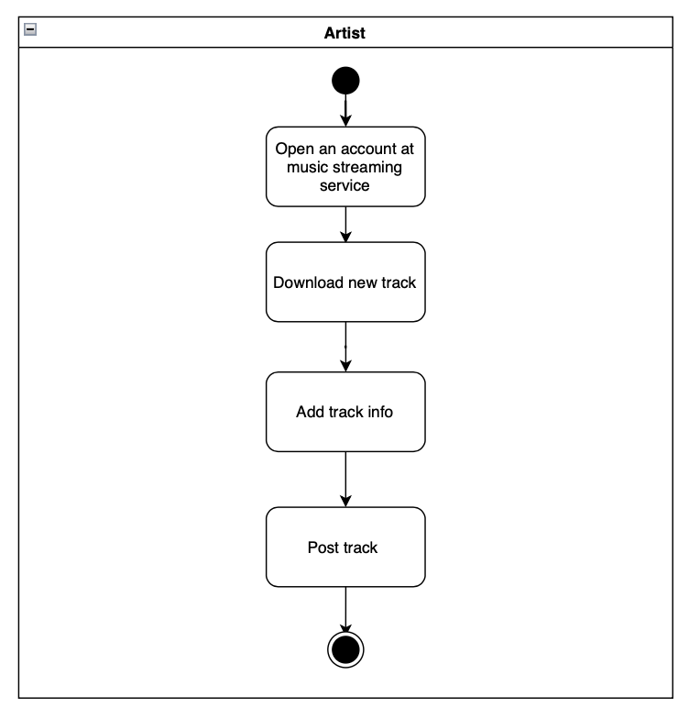

Figure 3. UML activity diagram for adding track

# Data modeling

### List of core domain entities

### Track User Album Artist Genre Playlist Subscription Transaction

The conceptual data model in Chen notation is a graphical representation used to describe the high-level structure and relationships of data in an information system. The Chen notation employs specific symbols and connectors to depict entities, attributes, and relationships. Here are the key elements of the Chen notation for conceptual data modeling:

1. Entity: Represents a real-world object, concept, or thing in the domain being modeled. It is depicted as a rectangle with the entity name written inside.
2. Attribute: Describes a characteristic or property of an entity. It is represented as an oval shape connected to the entity it belongs to. The attribute name is written inside the oval.
3. Relationship: Represents an association or connection between two or more entities. It is depicted as a diamond shape connecting the related entities. The relationship name is written inside the diamond.
4. Cardinality: Indicates the number of instances of one entity that can be associated with the instances of another entity in a relationship. Cardinality is represented using notations such as "1" (one), "M" (many), or numerical ranges.
5. Primary Key: Identifies a unique identifier for an entity. It is underlined within the entity rectangle.
6. Connectivity: Describes the participation of entities in a relationship. It can be either "optional" (represented by a circle at the end of a relationship line) or "mandatory" (no circle).

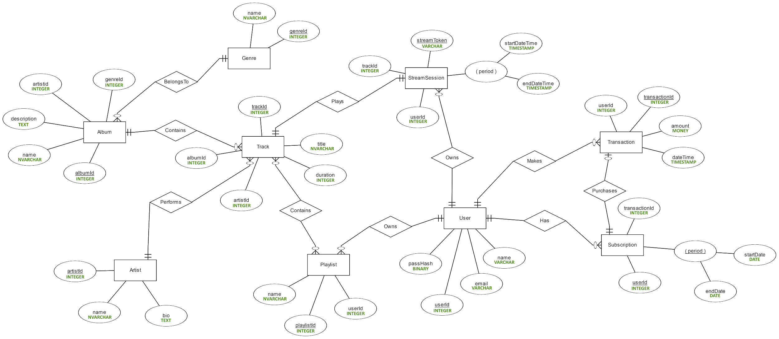

Figure 4. Conceptual data model

To create this model we use ERD Plus. ERD Plus is an online platform that provides tools and features for creating Entity Relationship Diagrams (ERDs). ERD Plus offers a user-friendly interface and a range of functionalities to help users design, visualize, and document their database models

## Next step is logical data modeling. ERwin is a popular data modeling tool that allows users to create logical data models (LDMs) among other types of data models. A logical data model represents the logical structure and relationships of data within an organization, independent of any specific database management system or physical implementation.

We use IDEF1X notation is a standardized graphical notation used for logical data modeling. It was developed as part of the Integrated Definition for Information Modeling (IDEF1X) methodology, which aims to improve the clarity and consistency of data models. IDEF1X notation is particularly well-suited for conceptual and logical data modeling.

Key elements of IDEF1X notation include:

1. Entity: Represented as a rectangular box with the entity name inside. Entities represent real-world objects, concepts, or things that are of interest in the domain being modeled.
2. Attribute: Depicted as an oval shape connected to the entity it belongs to. Attributes describe properties or characteristics of an entity and provide detailed information about the entity's instances. Attribute names are written inside the oval.
3. Primary Key: Identified by underlining the attribute(s) that form the primary key within an entity. The primary key uniquely identifies each instance of the entity.
4. Relationships: Shown as lines connecting related entities. Relationships represent associations or connections between entities and define how they are related. The cardinality and participation constraints of relationships are indicated near the line ends.
5. Cardinality: Represented using crow's foot notation, which indicates the maximum number of occurrences of one entity that can be associated with another entity. Common cardinality notations include "1" (one), "0..1" (zero or one), "0..N" (zero or more), and "1..N" (one or more).
6. Identifying and Non-Identifying Relationships: Identifying relationships are denoted with a solid line, while non-identifying relationships are represented with a dashed line. An identifying relationship means that the primary key of the parent entity is part of the child entity's primary key.

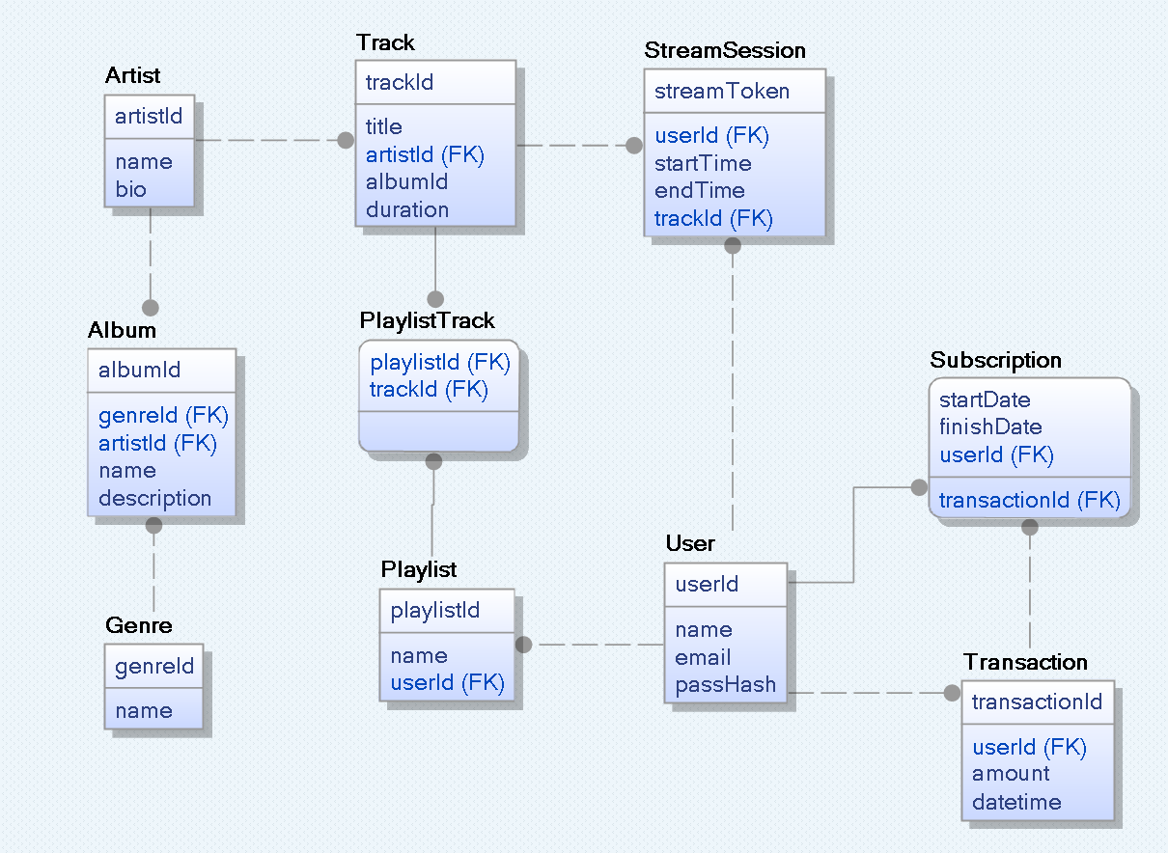

Figure 5. Logical data model in IDEF1X notation

## 

Figure 6. Physical data model

# Database formation

We chose Microsoft SQL Server DBMS for our work.Microsoft SQL Server is a popular Relational Database Management System (RDBMS) that offers several advantages for organizations:

1. Robust and Stable: SQL Server is known for its stability, reliability, and robustness. It is designed to handle large-scale, mission-critical databases with high performance and uptime.
2. Scalability: SQL Server provides scalability options, allowing organizations to handle growing data volumes and increasing user loads. It supports horizontal and vertical scaling, partitioning, and distributed query processing for efficient data management.
3. Security: SQL Server offers advanced security features to protect sensitive data. It includes features such as encryption, authentication mechanisms, fine-grained access control, auditing, and compliance tools to ensure data privacy and meet regulatory requirements.
4. Integration with Microsoft Ecosystem: SQL Server integrates seamlessly with other Microsoft products and technologies. It has native integration with Visual Studio, Azure services, Power BI, and other Microsoft tools, enabling a cohesive and comprehensive data management and analytics ecosystem.
5. Business Intelligence and Analytics: SQL Server includes robust business intelligence and analytics capabilities. It provides tools like SQL Server Analysis Services (SSAS), SQL Server Reporting Services (SSRS), and SQL Server Integration Services (SSIS) for data integration, reporting, and analysis.
6. Developer-Friendly: SQL Server offers extensive support for multiple programming languages and frameworks, making it developer-friendly. It provides tools like SQL Server Management Studio (SSMS) and Visual Studio for database development, debugging, and performance tuning.
7. High Availability and Disaster Recovery: SQL Server offers various high availability options, such as database mirroring, log shipping, failover clustering, and Always On Availability Groups. These features ensure data availability and provide disaster recovery capabilities.
8. Support and Community: SQL Server has a large user community and strong support from Microsoft. There are ample resources, documentation, forums, and user groups available for assistance, troubleshooting, and knowledge sharing.

Overall, Microsoft SQL Server is a comprehensive and feature-rich DBMS that provides organizations with a reliable, scalable, and secure platform for managing their data, supporting business intelligence initiatives, and enabling efficient application development.

To place our database there, we used the following SQL script.

CREATE TABLE [Artist]

(

artistId INT IDENTITY NOT NULL,

name NVARCHAR(64) NOT NULL,

bio TEXT,

-----------

PRIMARY KEY (artistId),

);

CREATE TABLE [Genre]

(

genreId INT IDENTITY NOT NULL,

name NVARCHAR(32) NOT NULL,

-----------

PRIMARY KEY (genreId),

);

CREATE TABLE [Album]

(

albumId INT IDENTITY NOT NULL,

genreId INT NOT NULL,

artistId INT NOT NULL,

name NVARCHAR(64) NOT NULL,

description TEXT,

-----------

PRIMARY KEY (albumId),

-----------

FOREIGN KEY (artistId) REFERENCES [Artist] (artistId),

FOREIGN KEY (genreId) REFERENCES [Genre] (genreId),

);

CREATE TABLE [Track]

(

trackId INT IDENTITY NOT NULL,

title NVARCHAR(64) NOT NULL,

artistId INT NOT NULL,

albumId INT NOT NULL,

duration INT NOT NULL,

-----------

PRIMARY KEY (trackId),

-----------

FOREIGN KEY (artistId) REFERENCES [Artist] (artistId),

FOREIGN KEY (albumId) REFERENCES [Album] (albumId),

);

CREATE TABLE [User]

(

userId INT IDENTITY NOT NULL,

name VARCHAR(32) NOT NULL,

email VARCHAR(32) NOT NULL,

passHash BINARY NOT NULL,

isActive BIT NOT NULL,

-----------

UNIQUE (email),

PRIMARY KEY (userId),

);

CREATE TABLE [Playlist]

(

playlistId INT IDENTITY NOT NULL,

name NVARCHAR(64) NOT NULL,

userId INT NOT NULL,

-----------

PRIMARY KEY (playlistId),

-----------

FOREIGN KEY (userId) REFERENCES [User] (userId),

);

CREATE TABLE [PlaylistTrack]

(

playlistId INT NOT NULL,

trackId INT NOT NULL,

-----------

PRIMARY KEY (playlistId, trackId),

-----------

FOREIGN KEY (playlistId) REFERENCES [Playlist] (playlistId),

FOREIGN KEY (trackId) REFERENCES [Track] (trackId),

);

CREATE TABLE [Transaction]

(

transactionId INT IDENTITY NOT NULL,

amount MONEY NOT NULL,

datetime DATETIME NOT NULL,

-----------

PRIMARY KEY (transactionId),

);

CREATE TABLE [Subscription]

(

startDate DATE NOT NULL,

endDate DATE NOT NULL,

userId INT NOT NULL,

transactionId INT NOT NULL,

-----------

PRIMARY KEY (startDate, endDate, userId),

-----------

FOREIGN KEY (userId) REFERENCES [User] (userId),

FOREIGN KEY (transactionId) REFERENCES [Transaction] (transactionId),

);

CREATE TABLE [StreamSession]

(

streamToken VARCHAR(128) NOT NULL,

userId INT NOT NULL,

trackId INT NOT NULL,

startTime DATETIME NOT NULL,

endTime DATETIME NOT NULL,

isActive BIT NOT NULL,

-----------

PRIMARY KEY (streamToken),

-----------

FOREIGN KEY (userId) REFERENCES [User] (userId),

FOREIGN KEY (trackId) REFERENCES [Track] (trackId),

);

We also create indexes. The aim of database indexes is to improve the performance and efficiency of database queries by enabling faster data retrieval. Indexes are data structures that provide a way to access data in a database more quickly, similar to the index in a book that allows you to quickly locate specific information.

Here are the main objectives or aims of database indexes:

1. Accelerate Data Retrieval: Indexes are created on specific columns or combinations of columns in a database table. By creating an index, the database system can locate and retrieve the required data more efficiently. Instead of scanning the entire table, the database engine can use the index to quickly narrow down the search space and retrieve only the relevant data.
2. Improve Query Performance: Indexes can significantly improve the performance of queries that involve search, sorting, and joining operations. By using indexes, the database engine can execute queries more efficiently, reducing the time it takes to process and retrieve the desired results.
3. Enable Selectivity and Filtering: Indexes allow for efficient filtering and selectivity of data. When a query includes conditions or filters on indexed columns, the index can be utilized to quickly identify the matching rows and retrieve the results without scanning the entire table.
4. Facilitate Data Ordering: Indexes can be used to sort the data in a specific order, which can be beneficial for queries that require sorted results. By utilizing the index, the database engine can retrieve the data already in the desired order, eliminating the need for additional sorting operations.
5. Support Data Integrity and Constraints: Indexes can be used to enforce data integrity and enforce constraints, such as unique constraints and primary key constraints. These constraints ensure that the indexed columns have unique values, allowing for efficient enforcement and validation during data modification operations.
6. Optimize Joins and Aggregations: Indexes can improve the performance of join operations and aggregations by providing efficient access paths to the required data. By utilizing indexes on the join and aggregation columns, the database engine can minimize the need for full table scans and optimize the execution of these operations.

Below is a list of indexes that we have created to speed up query execution.

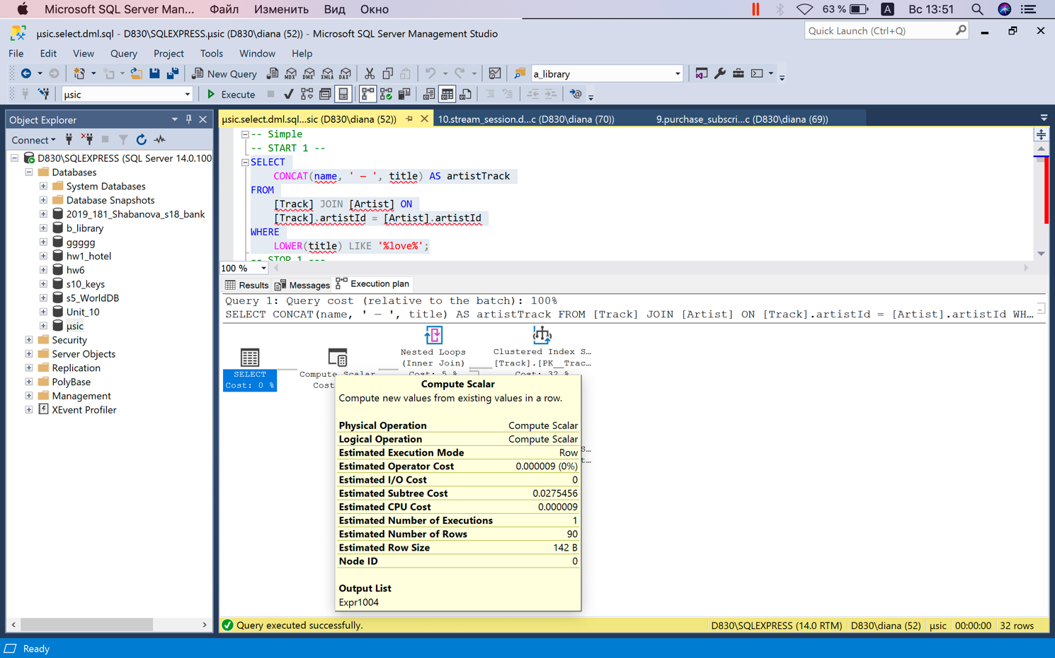

Query execution parameters before index creation

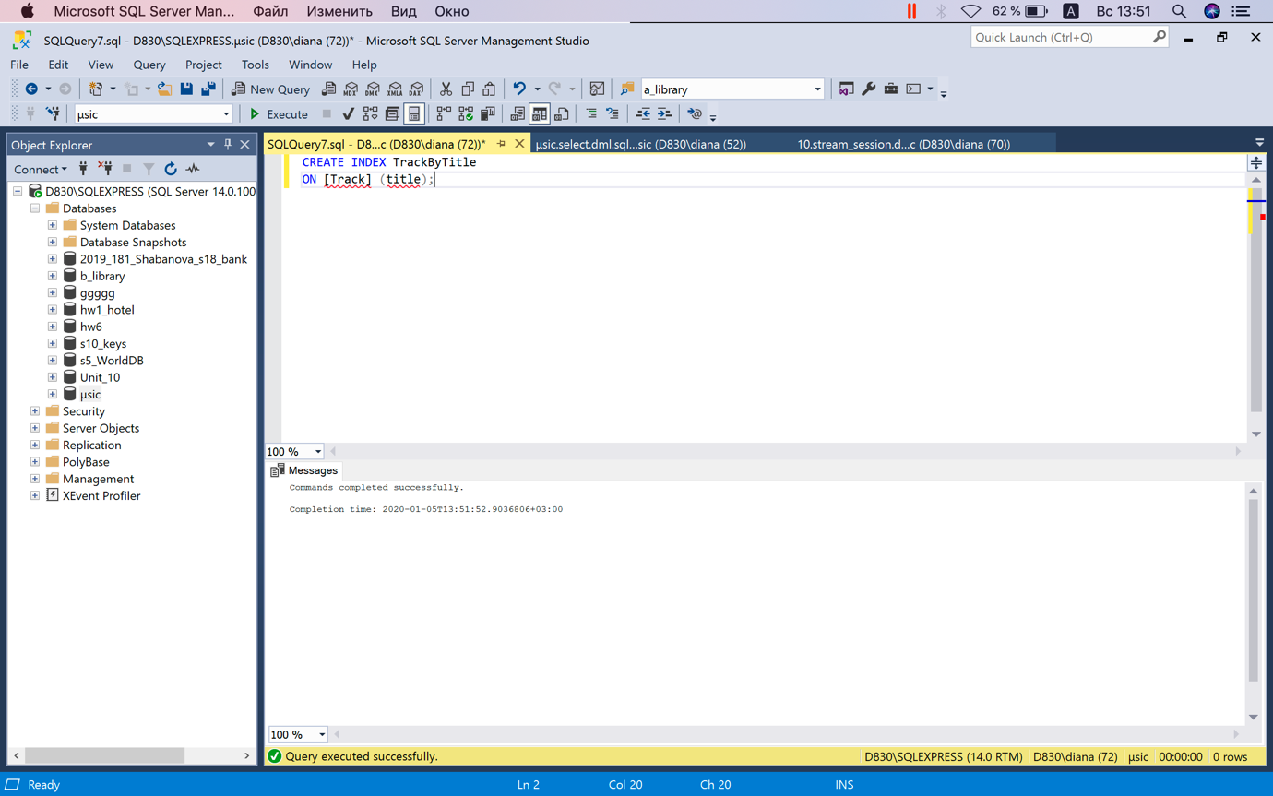

Creating an index

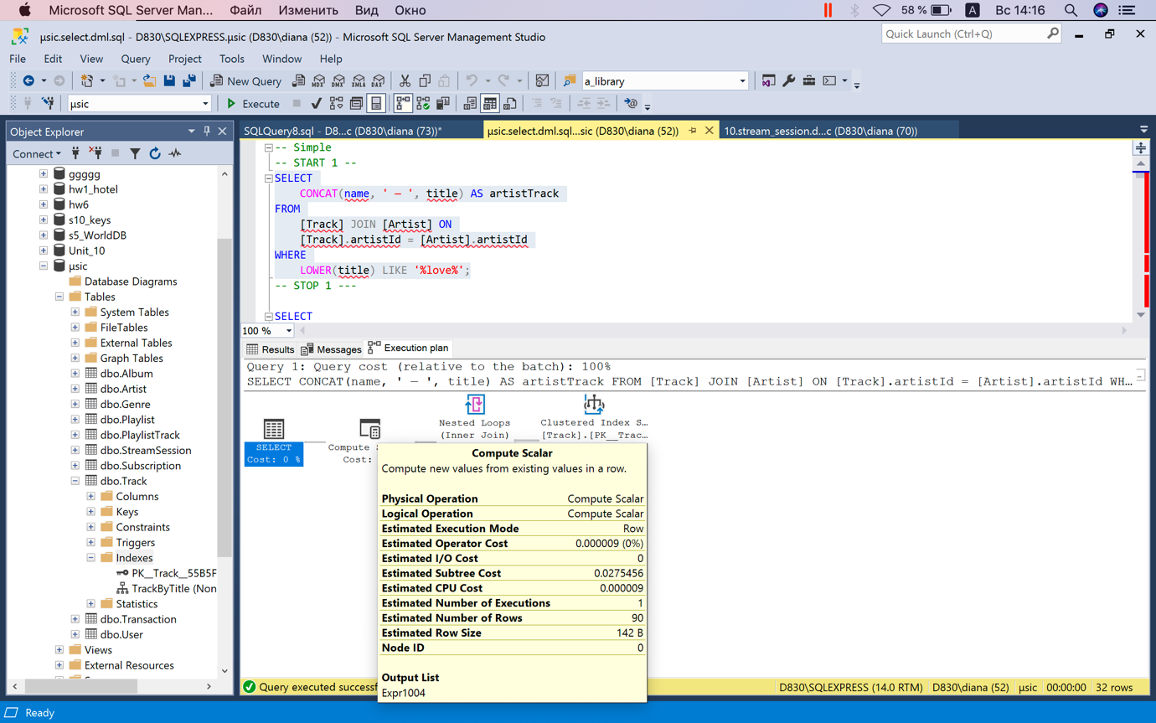

Query execution parameters before index creation

CREATE INDEX ArtistByName

ON [Artist] (name);

CREATE INDEX GenreByName

ON [Genre] (name);

CREATE INDEX AlbumByName

ON [Album] (name);

CREATE INDEX AlbumByGenre

ON [Album] (genreId);

CREATE INDEX TrackByTitle

ON [Track] (title);

CREATE INDEX PlaylistByName

ON [Playlist] (name);

# Data sources and data creation

First of all, we filled in the tables related to tracks, albums and musicians, the information on them was already present in the dataset, so we copied it and created scripts using excel, and then filled in the database.

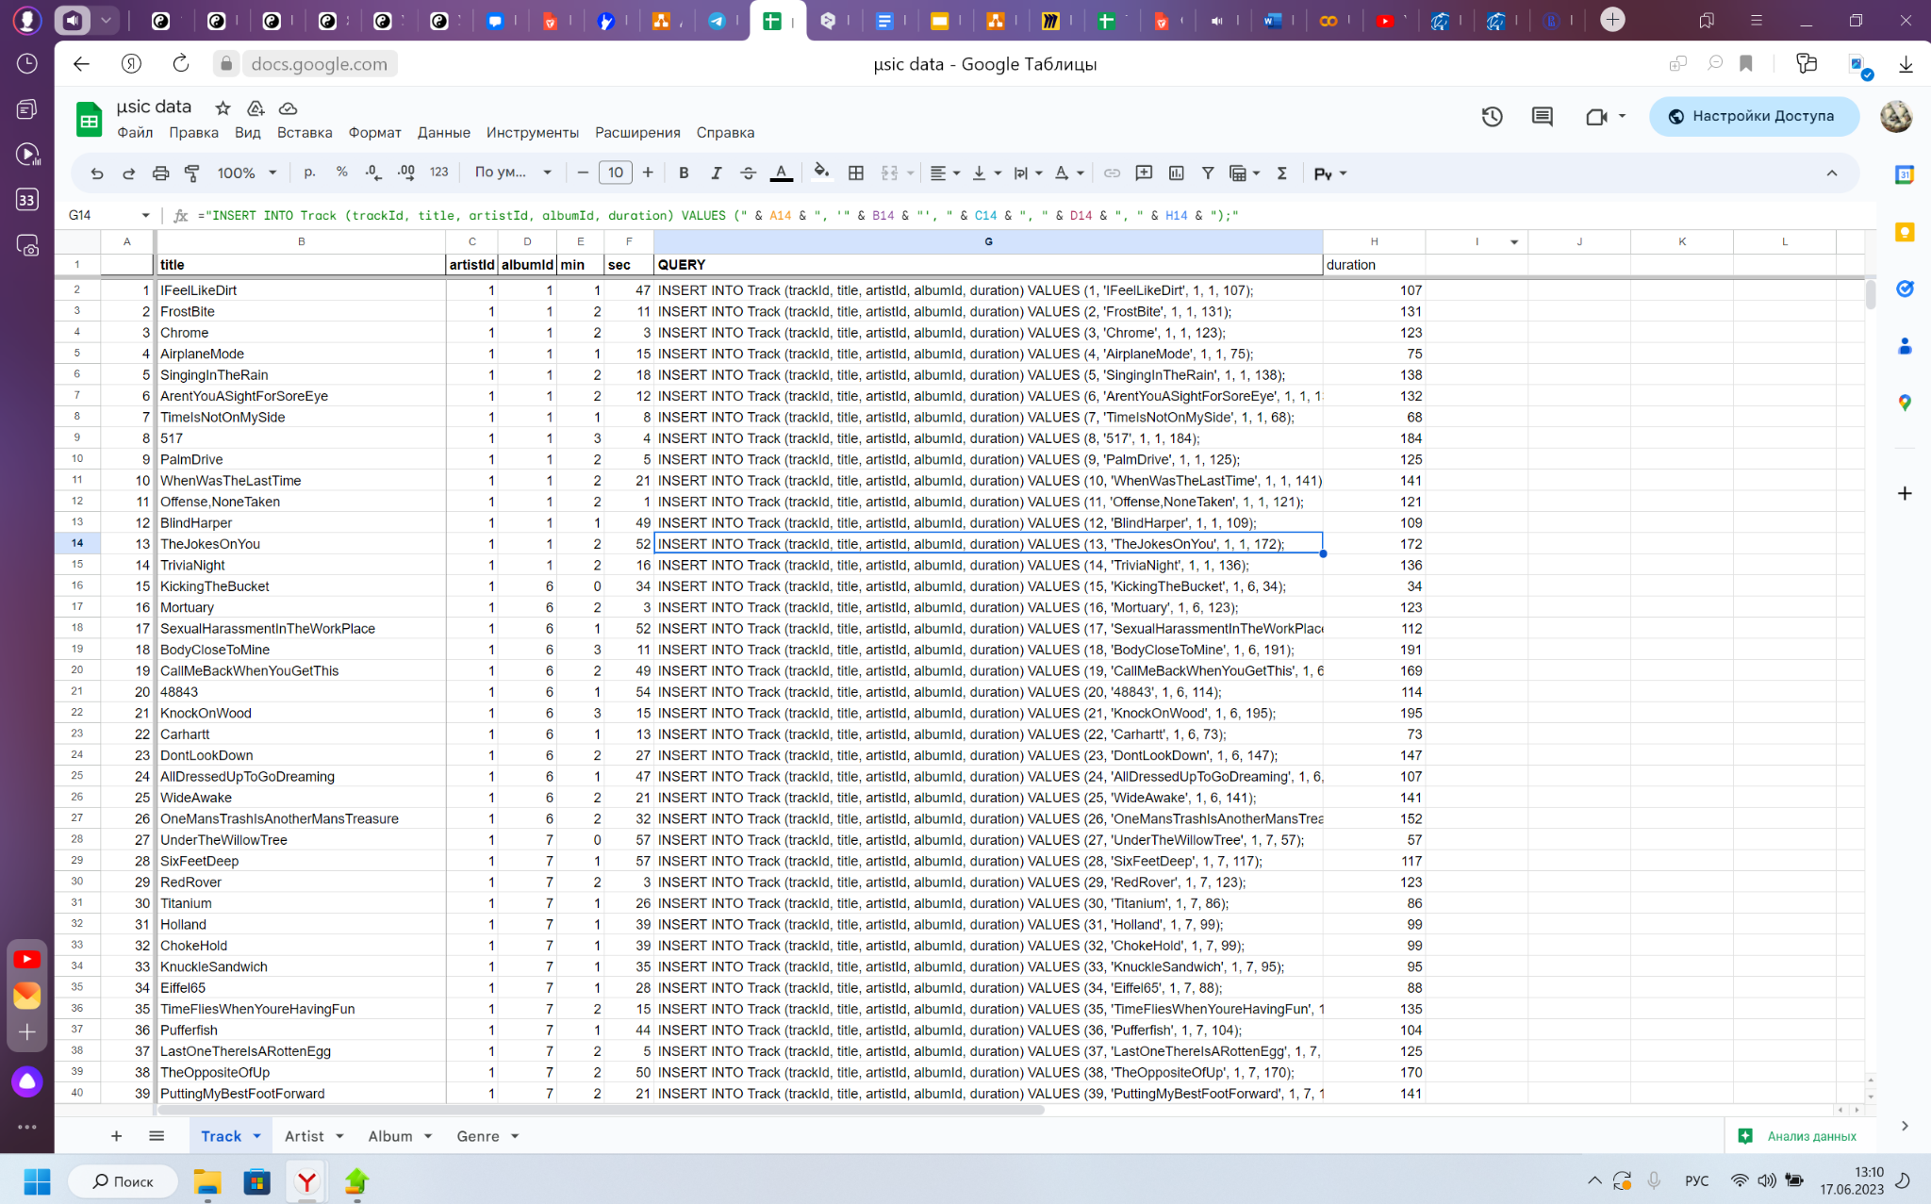

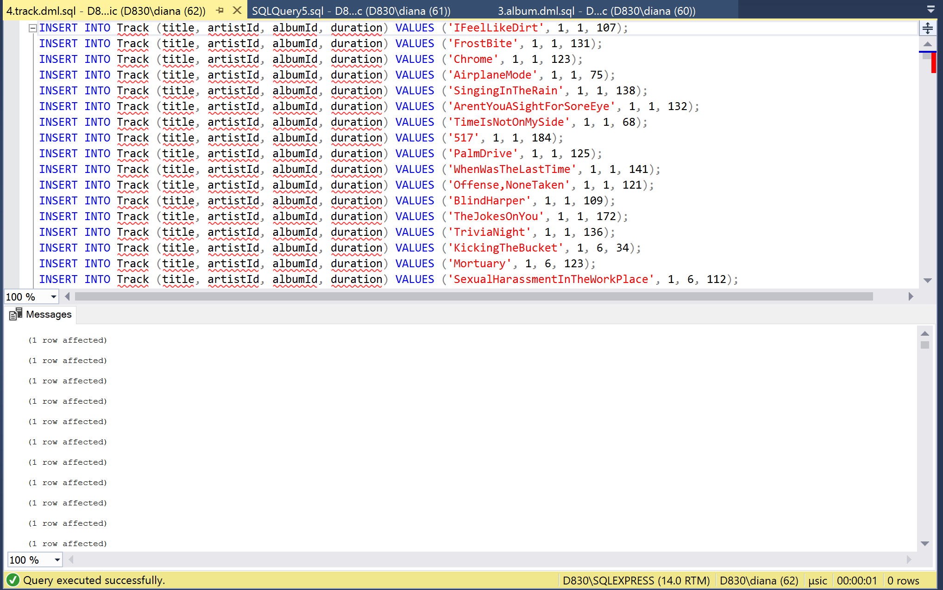

After that, we start to create a script to populate the Users table. This program produces a PLSQL script that can be inserted into any database where there are Users with the fields we specify. To randomize the data, we used the names library, because it contains the get_full_name method, we were able to randomly create records in the table.

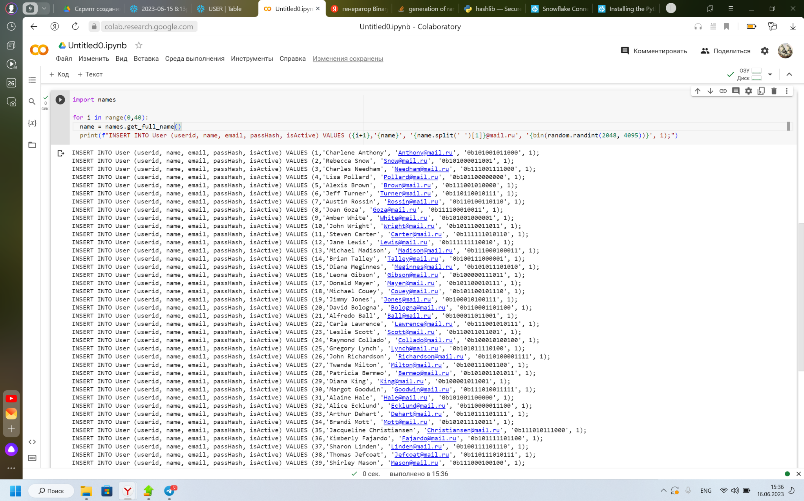

After that we proceeded to a more complex stage, filling the tables of transactions and subscriptions. These two tables are interrelated, because when the transaction from the user needs to create accordingly this transaction field subscription, with the fact that if the user currently has a subscription, its payment is aimed at renewing the existing subscription, so you need to create a new record, which will start at the end of the previous subscription. The pandas library and the DataFrame class from it were used to make it easier to check. In addition, libraries were integrated to interact with the format of dates in python. It was also considered that the price of a subscription is 100, so if the user pays more than that, it means that he bought a subscription for several months. Last but not least was the fact that the user does not always make a transaction every month, we set the probability that the user would make a transaction this month at 60%.

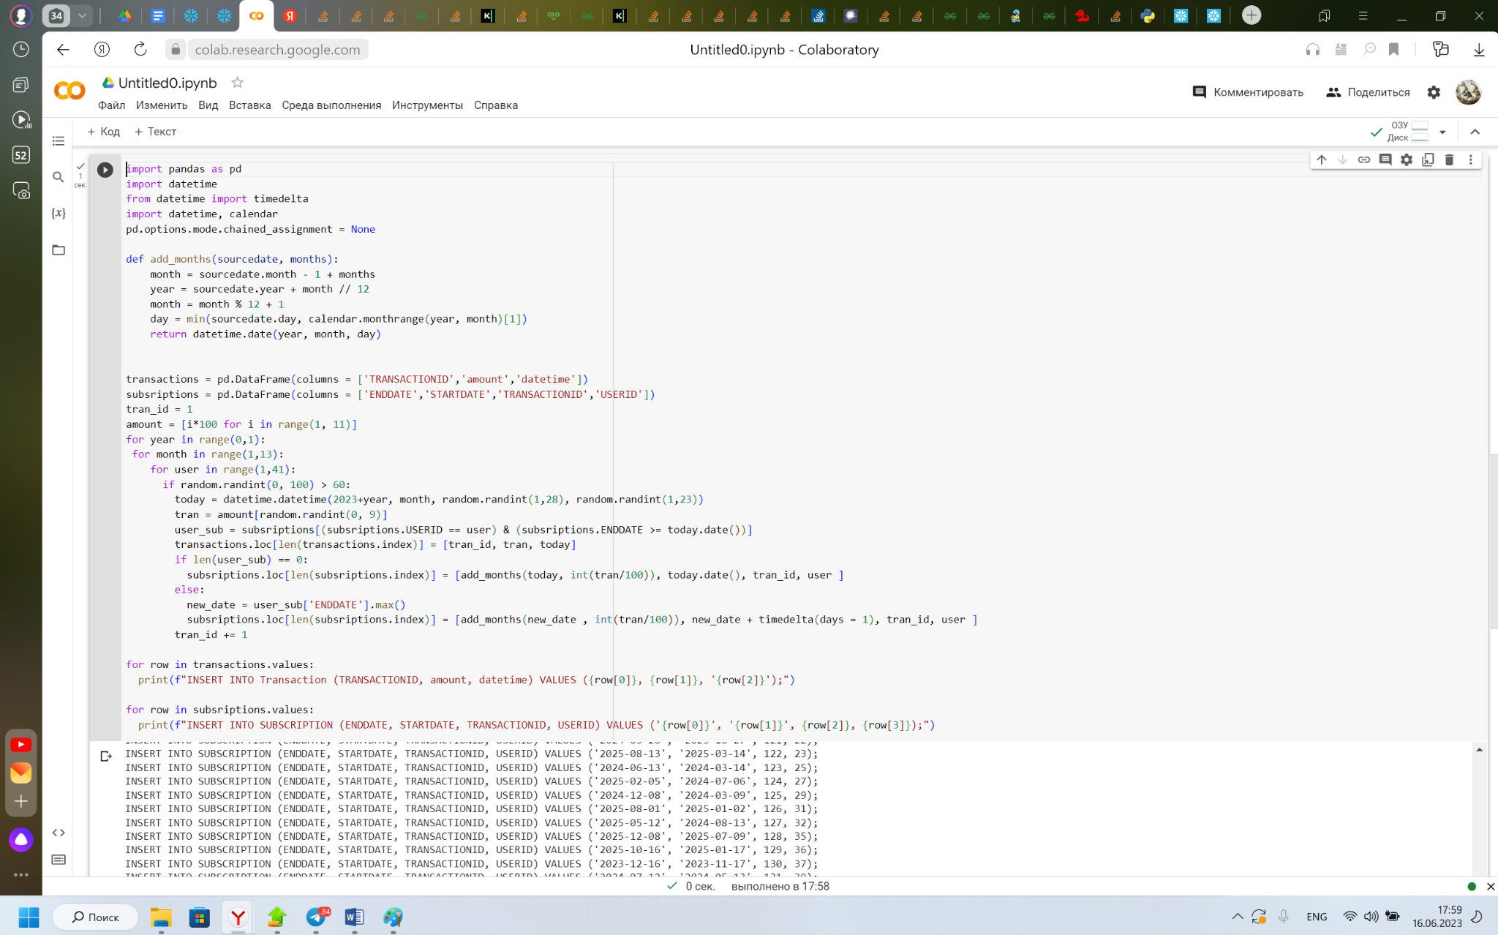

The next step was to populate the playlist table. Each user may or may not have many playlists, so we generated 200 playlist entries that randomly select the user. We also integrated the wordgenerator library so that the playlist names would be short and represent a random word.

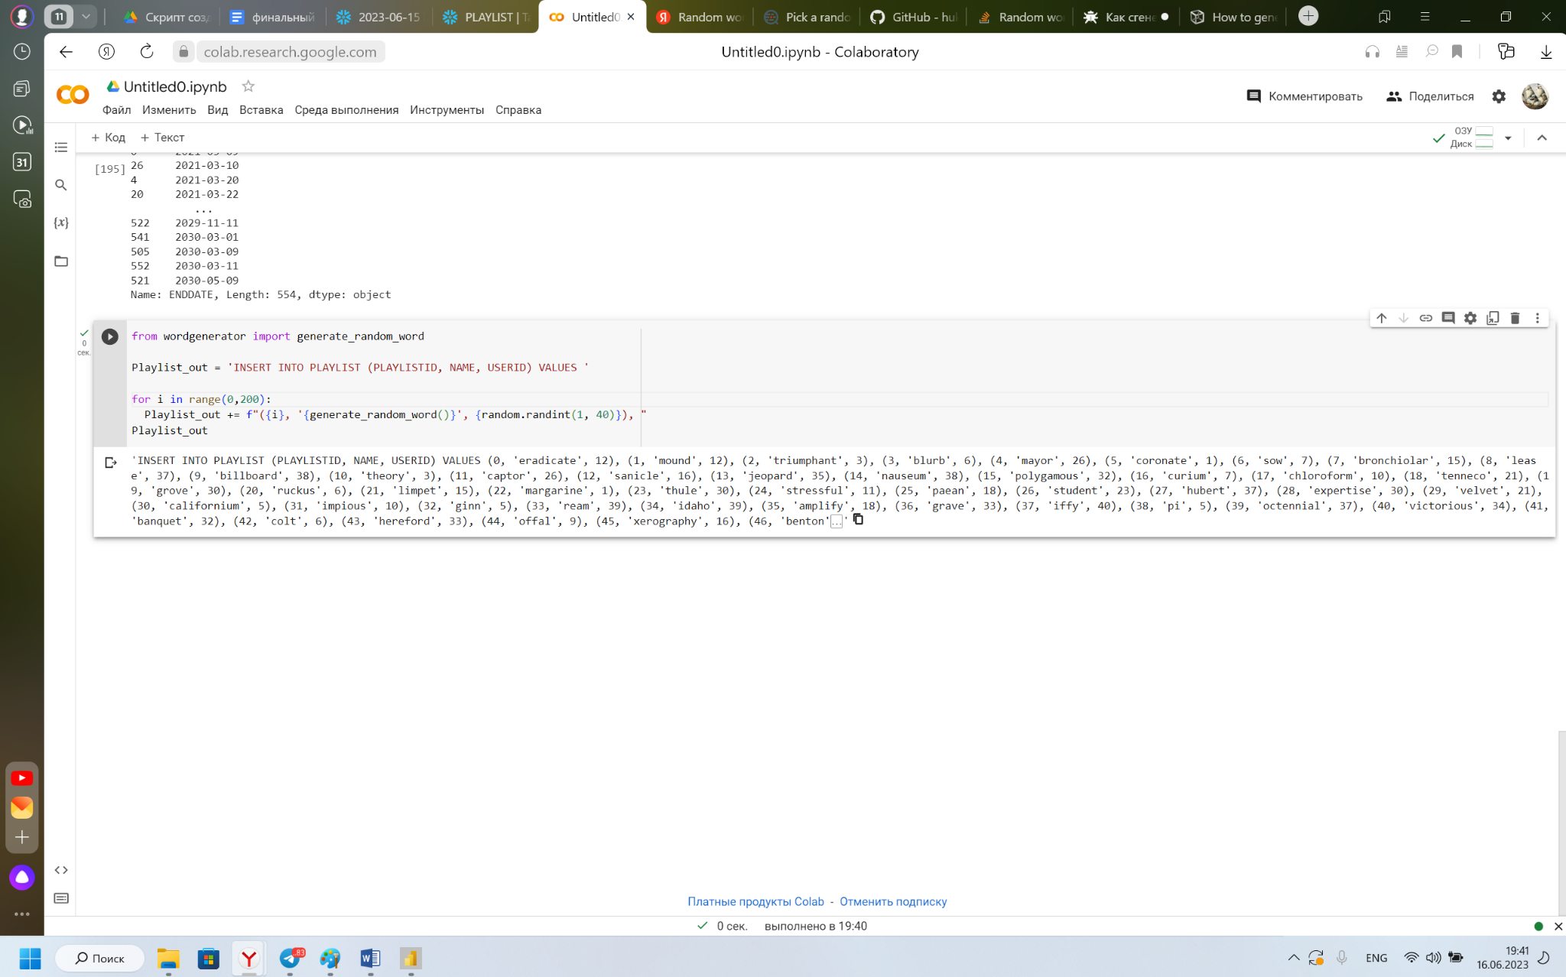

And the last table we filled is the PLAYLISTTRACK table, which contains information about the tracks in the playlists. Considering that playlists can be both empty and contain a lot of tracks, we made 10,000 entries that randomly select a playlist and a track that will be in it.

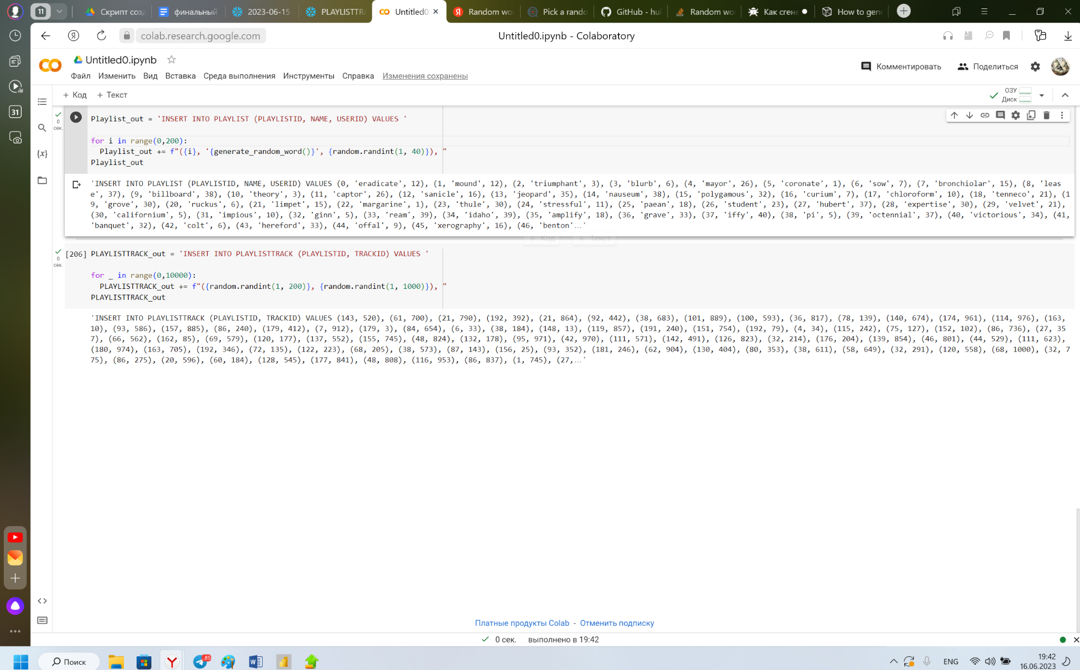

# Development of useful queries for the database

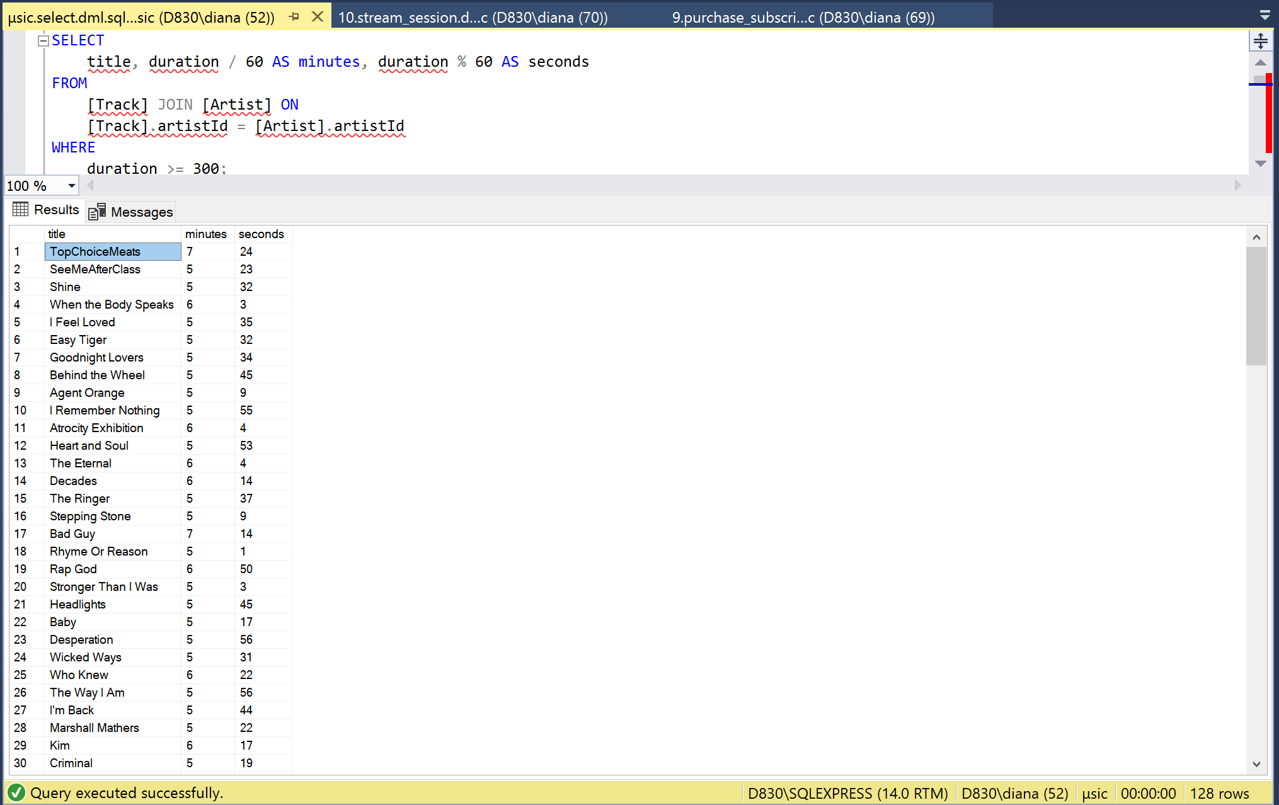

The request outputs tracks lasting more than 5 minutes

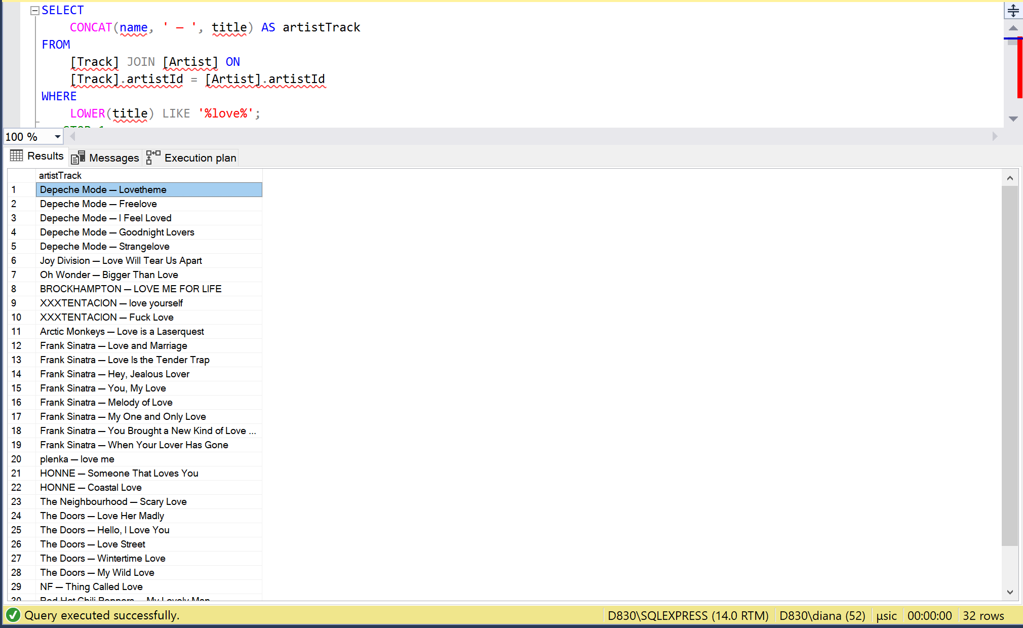

The query outputs tracks in the names of which the word “love” occurs

### 

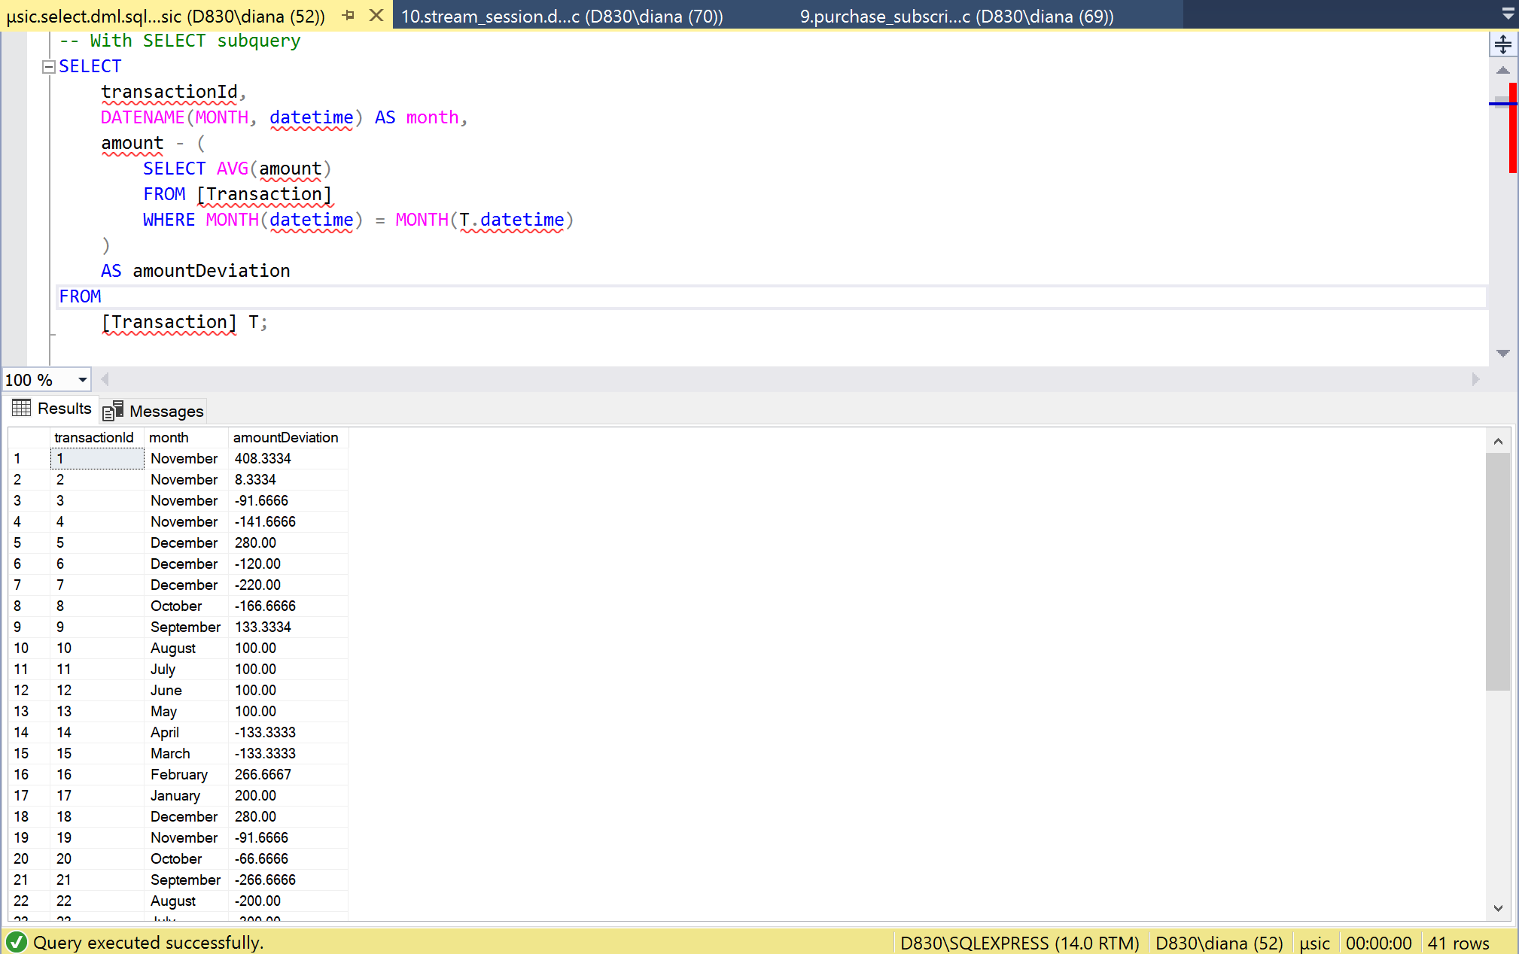

The query outputs the amount of deviation in transactions

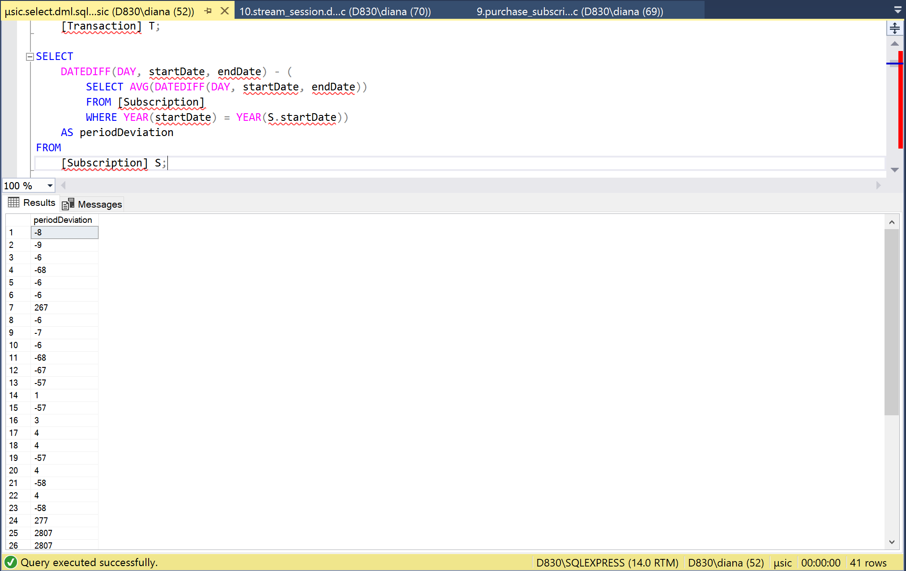

The request displays the rejection period in subscriptions

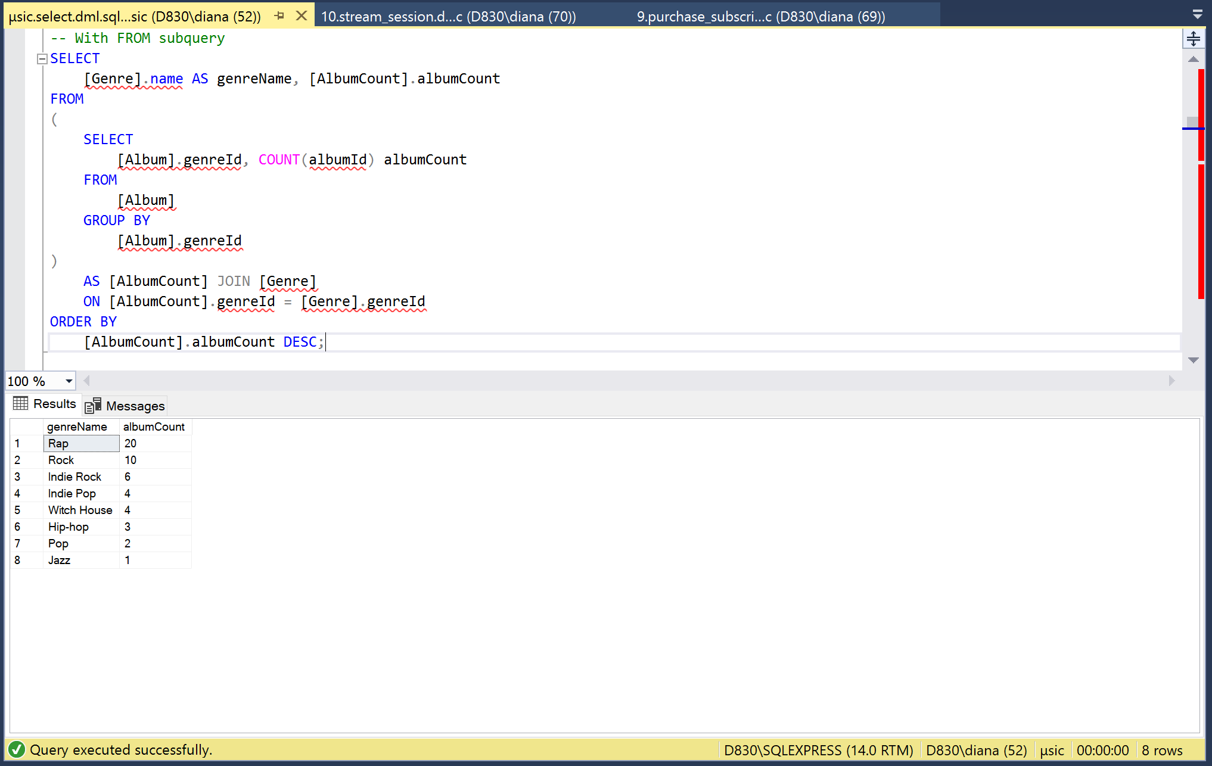

The query outputs the number of albums of each genre

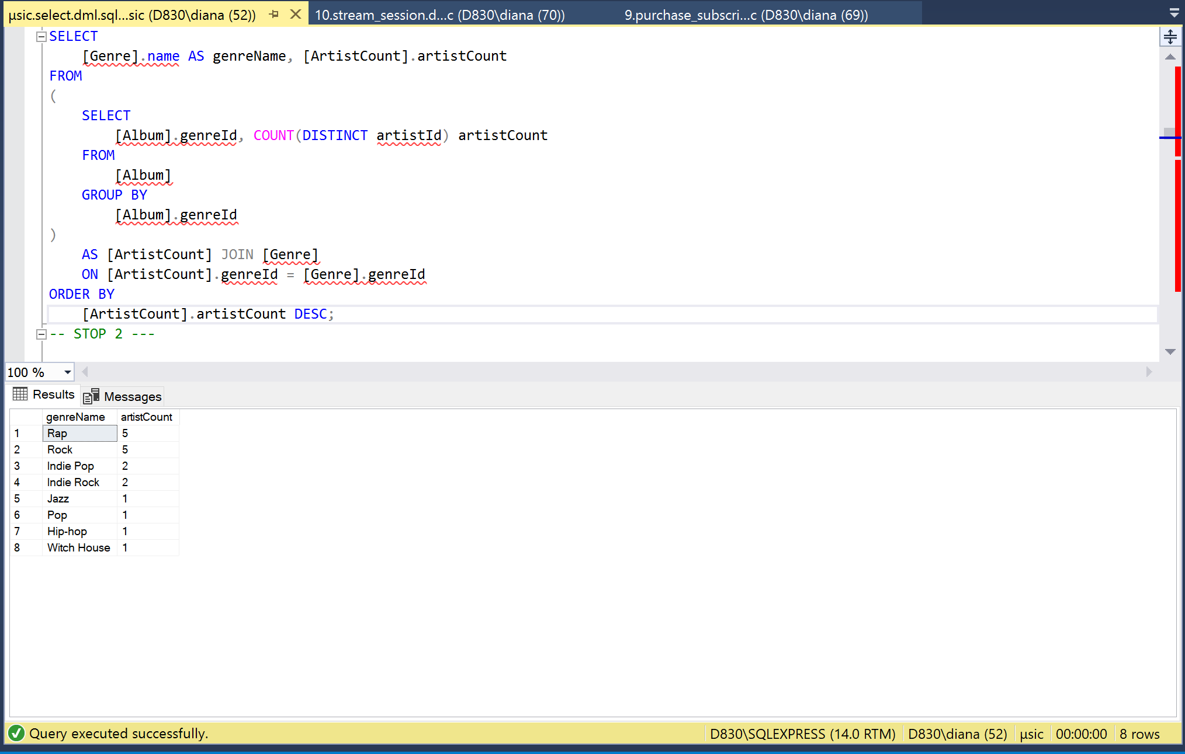

The query outputs the number of performers of each genre

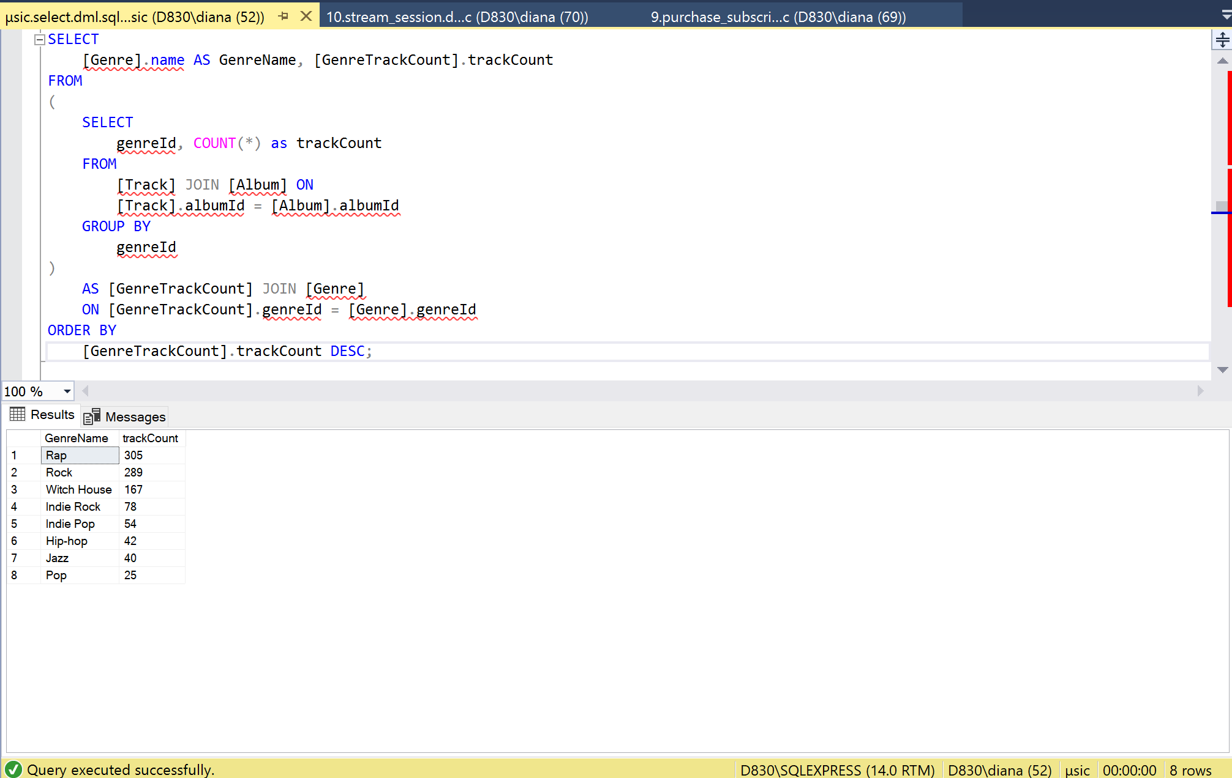

The query outputs the number of tracks of each genre

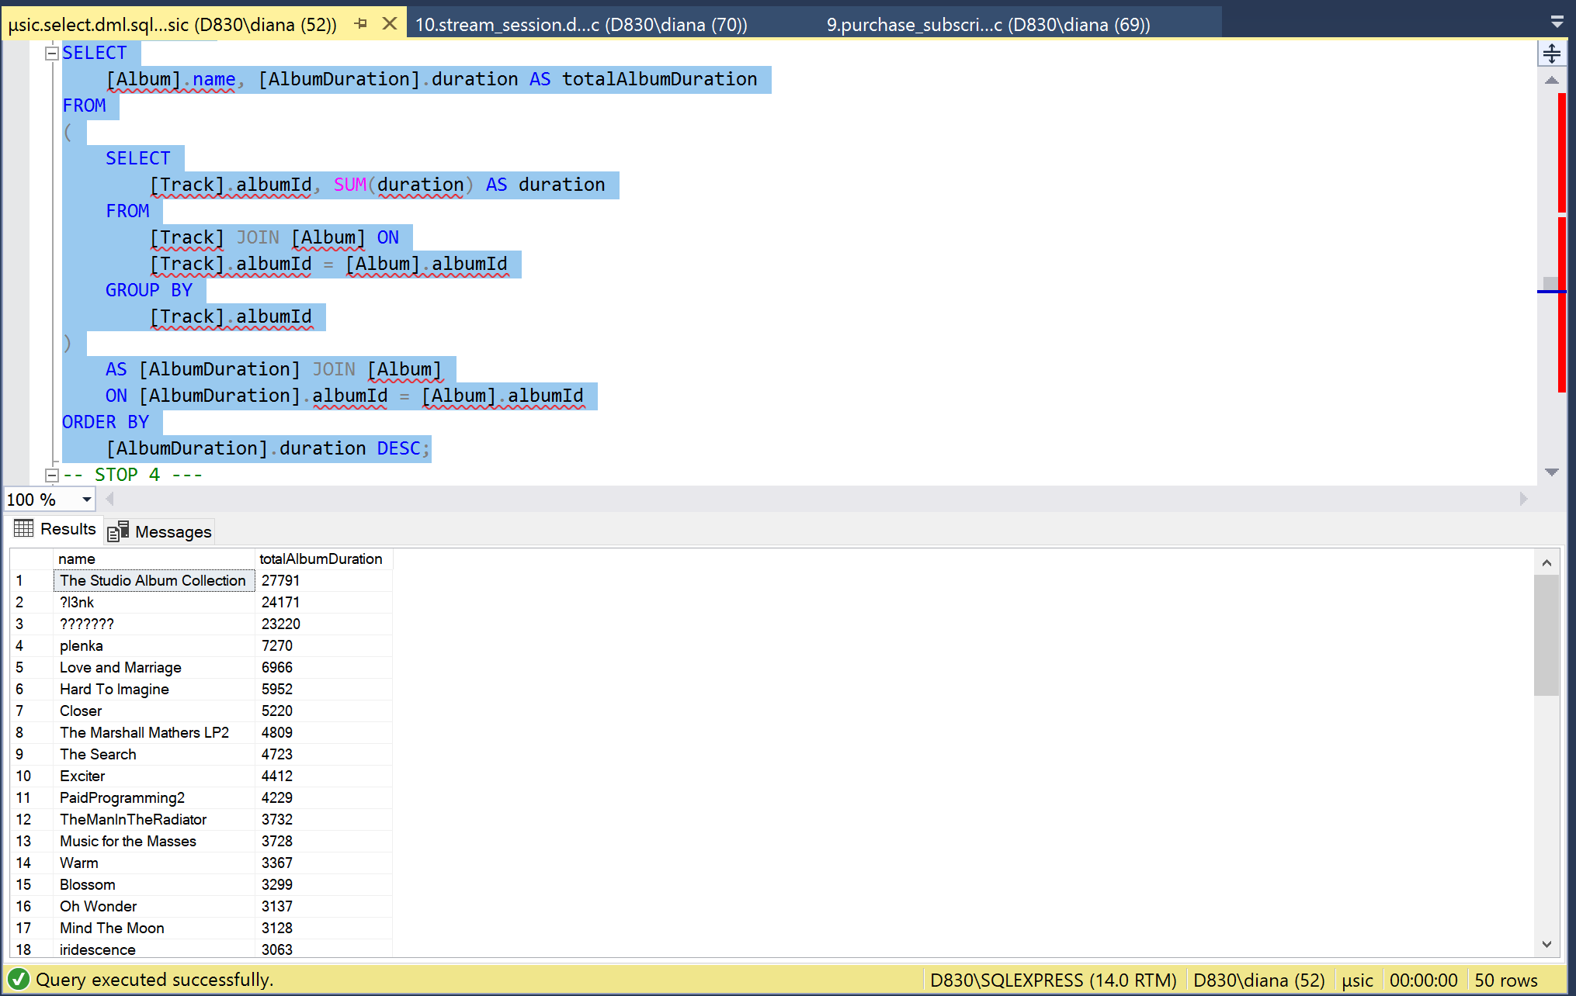

The query outputs the length of the album

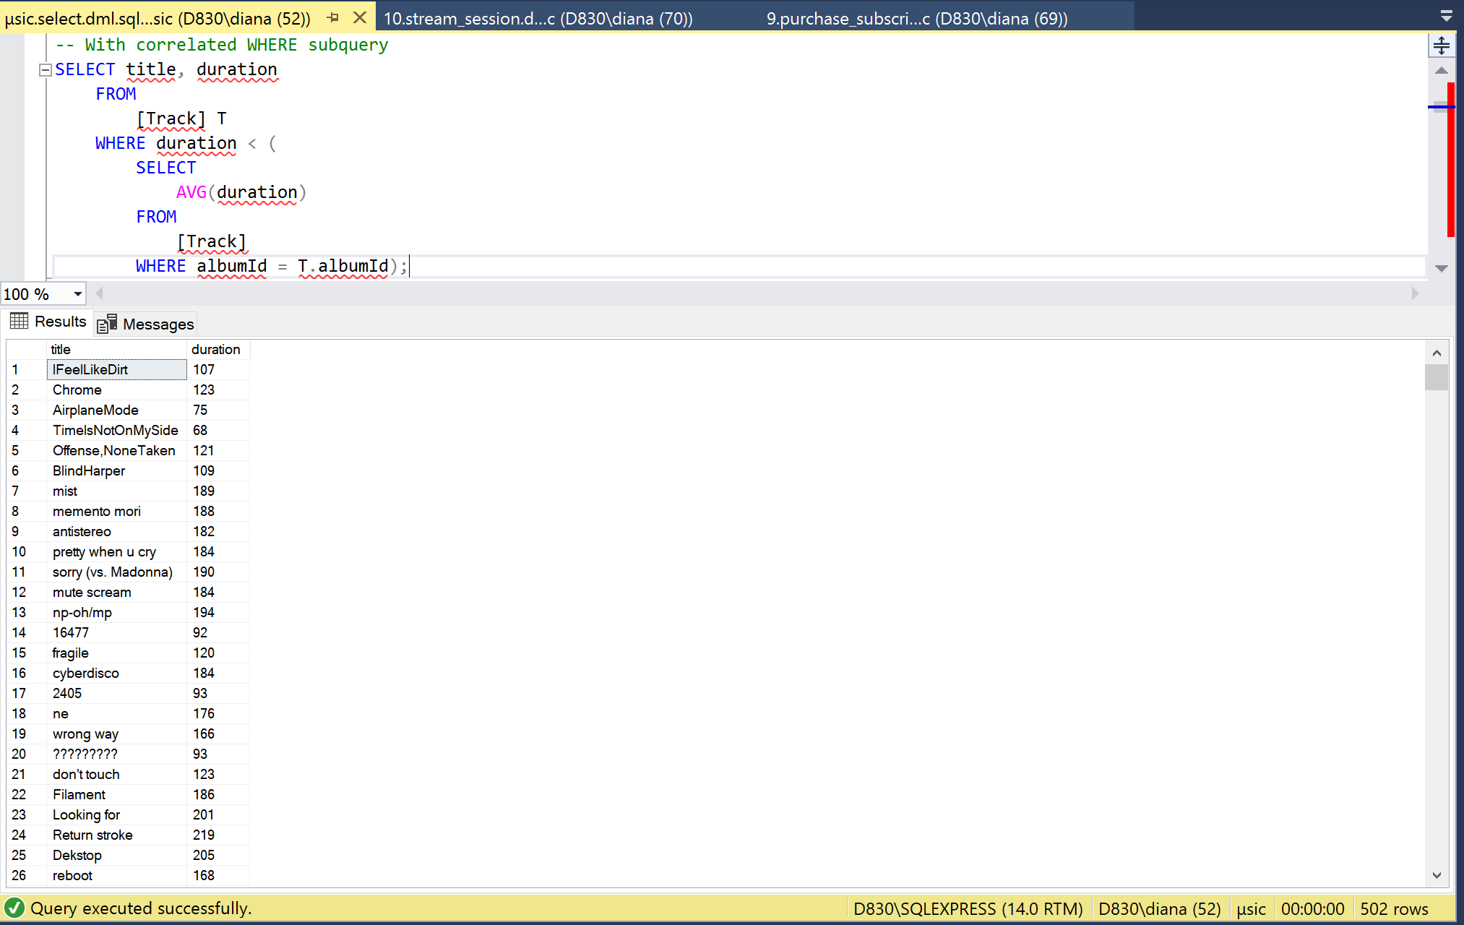

The query outputs tracks that are longer than the average track length in the album

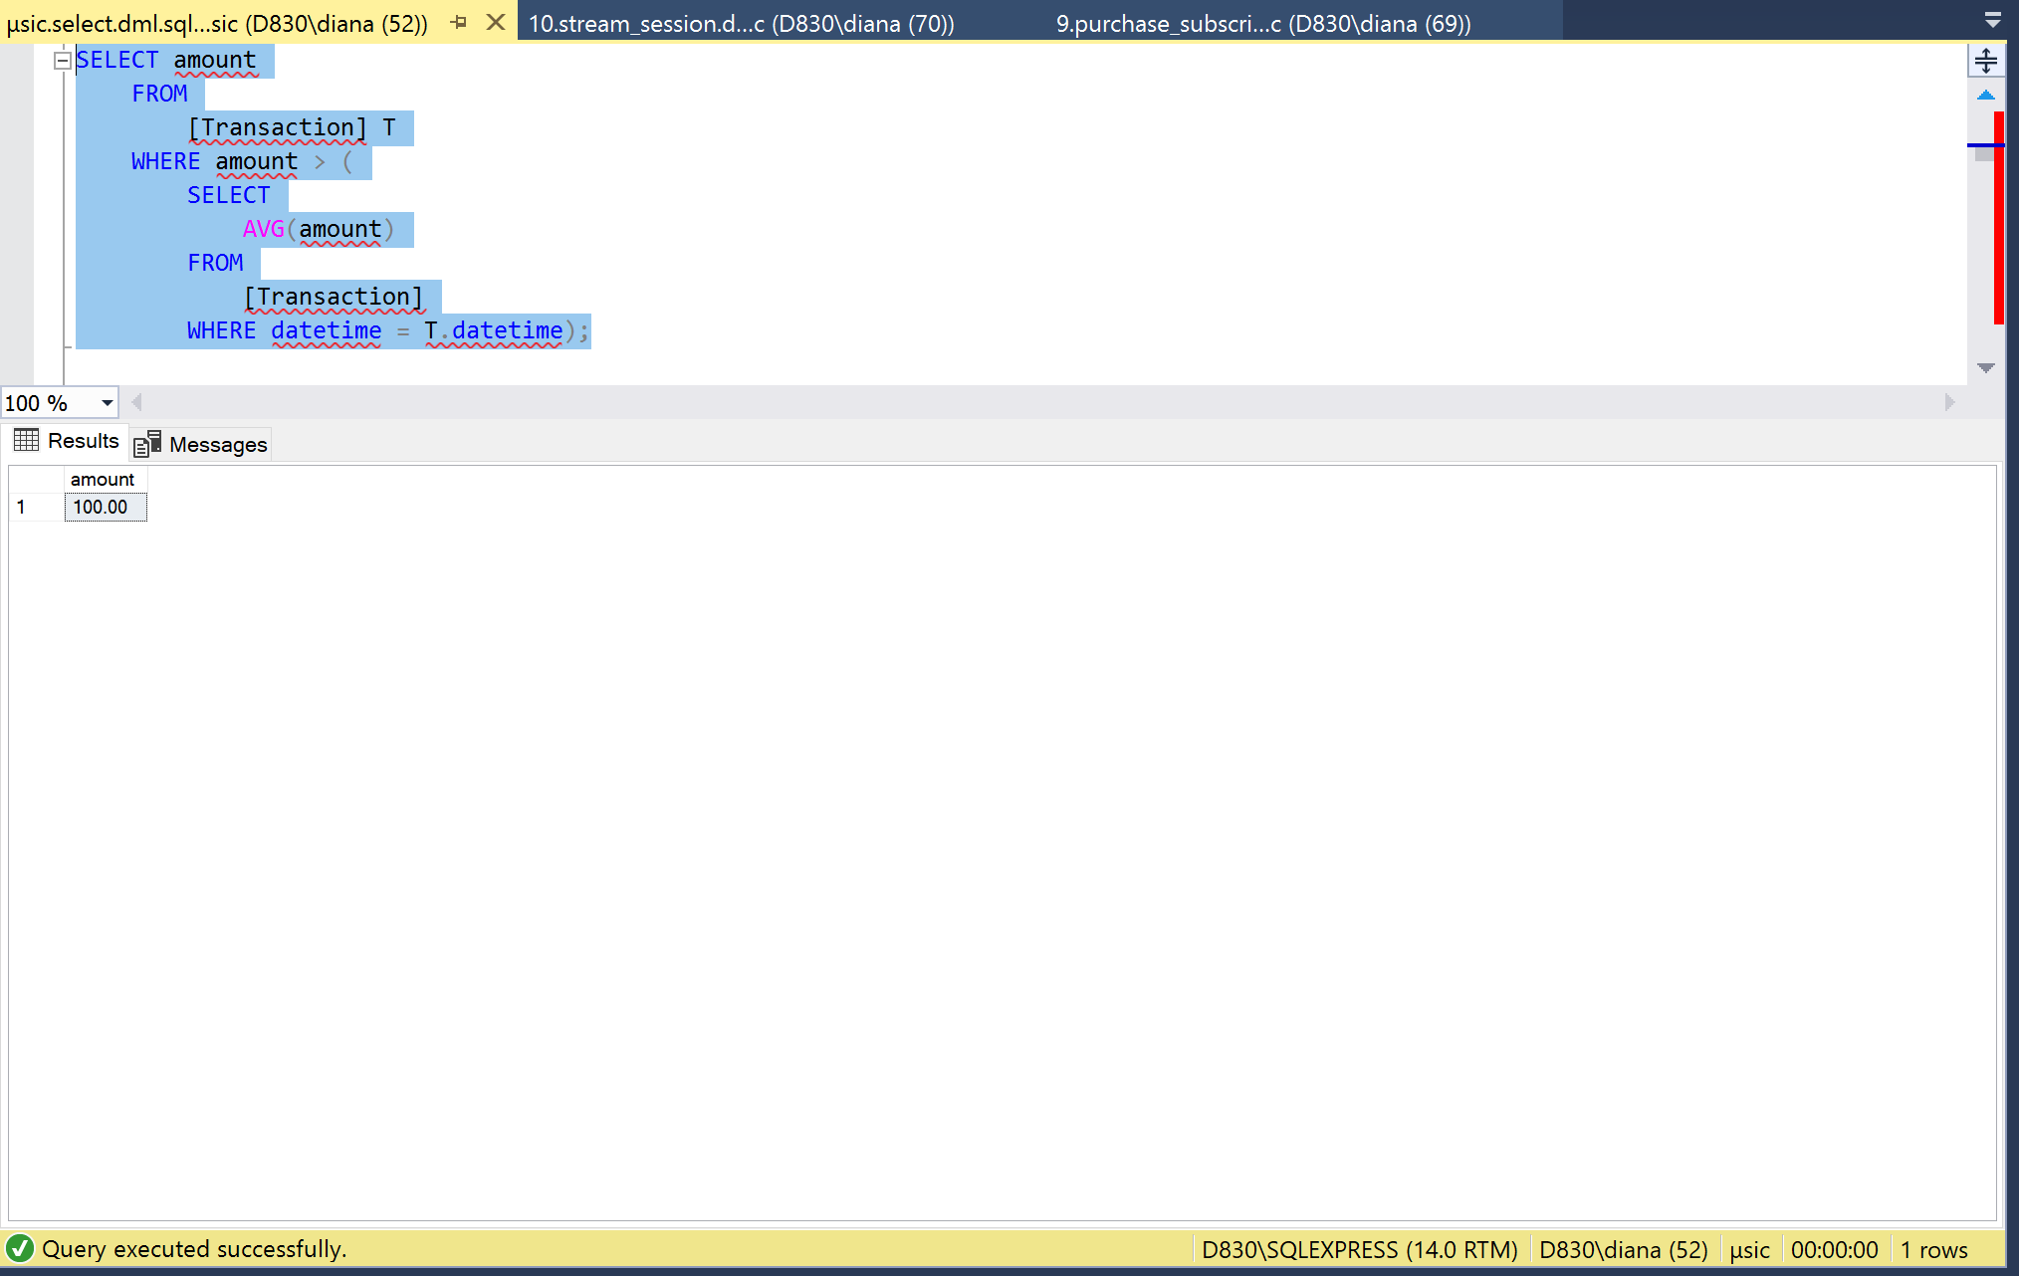

### 

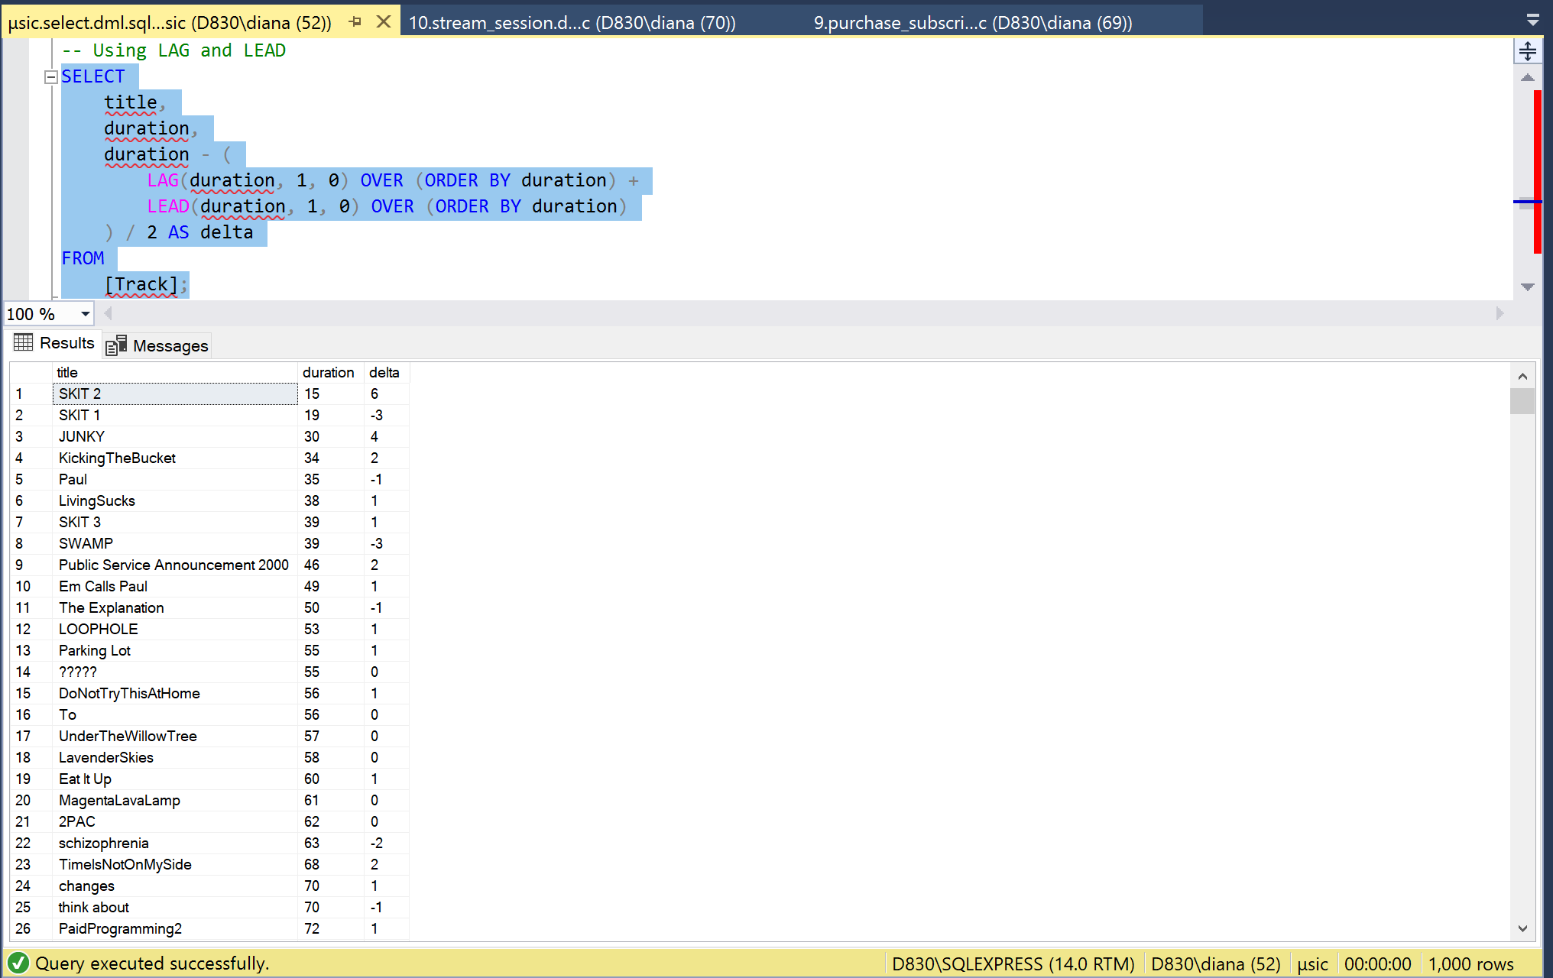

The query outputs the difference in the length of the tracks

### 

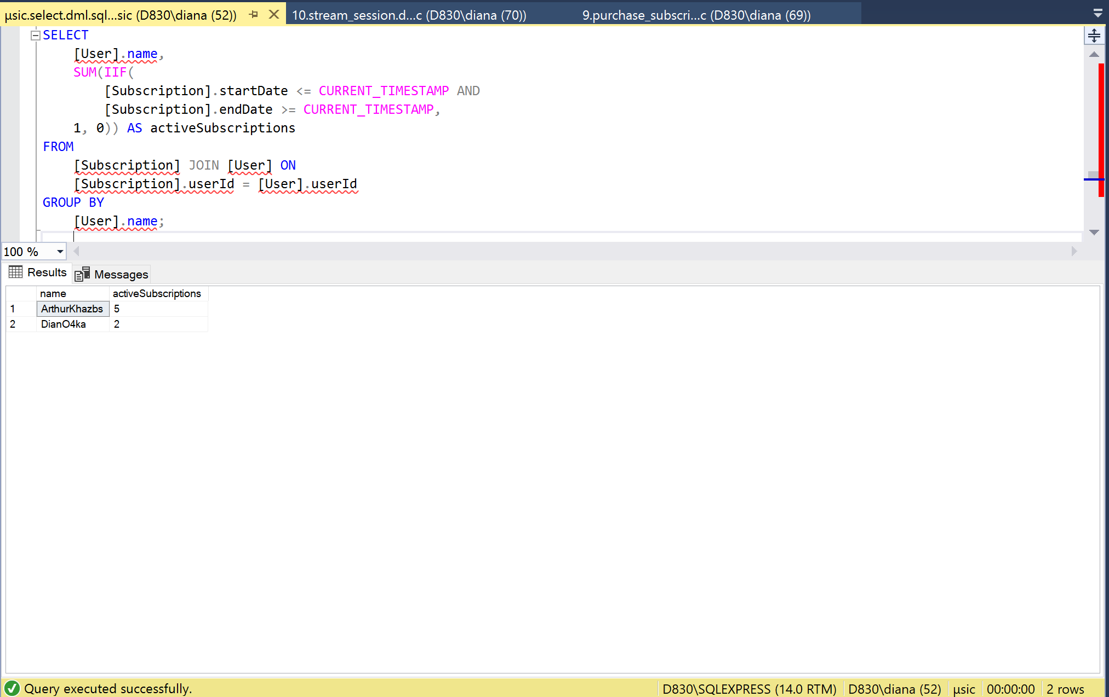

The query displays the number of active subscriptions of the user

### 

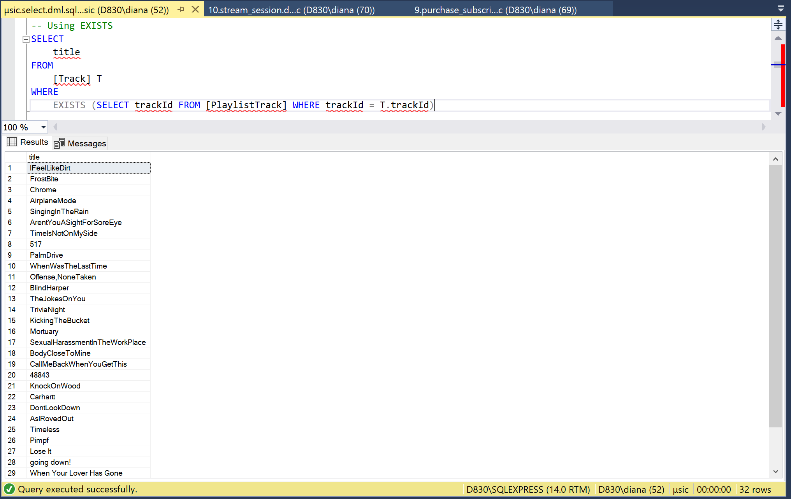

The request outputs tracks that are involved in playlists

### 

The query outputs tracks of all genres, except those genres that Arthur does not like

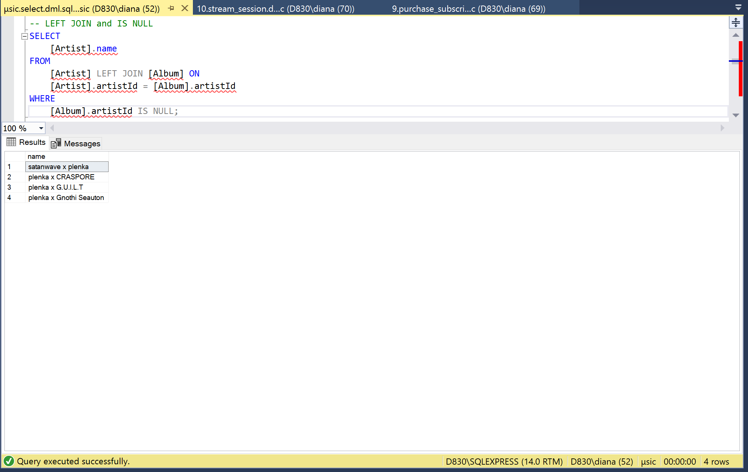

The query outputs fits

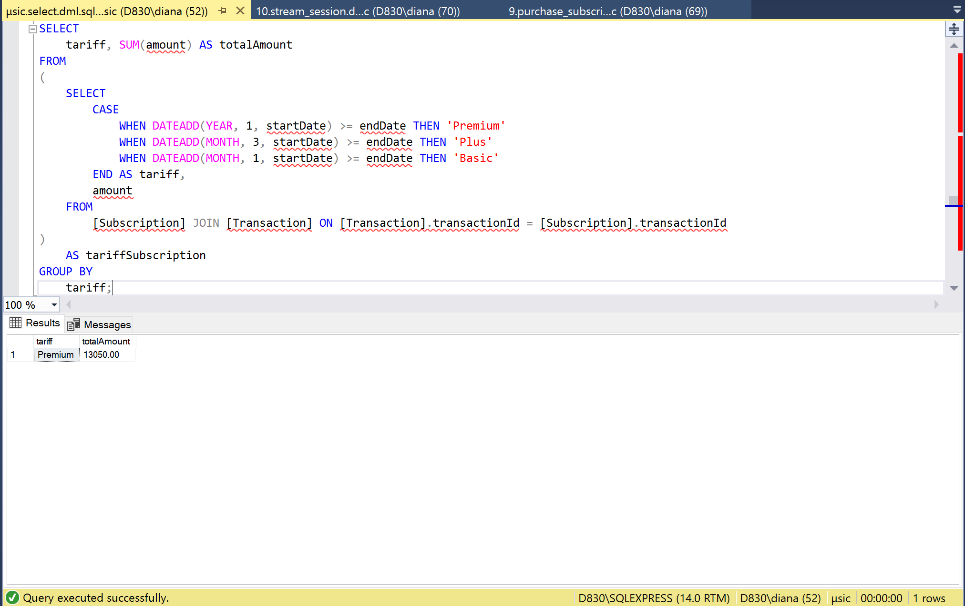

Запрос выводит тарифы и общую выручку сервиса

### SELECT INTO query to prepare the upload

SELECT

[User].name AS username,

[Playlist].name AS playlistName,

[Track].title AS trackTitle,

[Artist].name AS artistName

INTO

[FullPlaylistInfo]

FROM

[User] JOIN [Playlist] ON [User].userId = [Playlist].userId

JOIN [PlaylistTrack] ON [Playlist].playlistId = [PlaylistTrack].playlistId

JOIN [Track] ON [PlaylistTrack].trackId = [Track].trackId

JOIN [Artist] ON [Track].artistId = [Artist].artistId;

### query with PIVOT

### SELECT

[User].name,

IsNull([January], 0) AS January,

IsNull([February], 0) AS February,

IsNull([March], 0) AS March,

IsNull([April], 0) AS April,

IsNull([May], 0) AS May,

IsNull([June], 0) AS June,

IsNull([July], 0) AS July,

IsNull([August], 0) AS August,

IsNull([September], 0) AS September,

IsNull([October], 0) AS October,

IsNull([November], 0) AS November,

IsNull([December], 0) AS December

FROM

(

SELECT

[User].userId,

SUM(amount) AS revenueDriven,

DATENAME(MONTH, datetime) AS [Month]

FROM

[Transaction] JOIN [Subscription] ON [Transaction].transactionId = [Subscription].transactionId

JOIN [User] ON [User].userId = [Subscription].userId

GROUP BY

DATENAME(MONTH, datetime),

[User].userId

) AS T

PIVOT

(

SUM(revenueDriven)

FOR [Month] IN ([January], [February],

[March], [April], [May],

[June], [July], [August],

[September], [October], [November],

[December])

) AS P JOIN [User] ON P.userId = [User].userId;

# Creating stored procedures

------ Procedures ---

CREATE PROCEDURE AddTrack (

@title NVARCHAR(64),

@artistId INT,

@artistName NVARCHAR(64),

@albumId INT,

@albumName NVARCHAR(64),

@genreId INT,

@genreName NVARCHAR(64),

@duration INT

)

AS

BEGIN

DECLARE @artist TABLE (artistId INT);

IF (@artistId IS NULL)

INSERT INTO [Artist] (name, bio)

OUTPUT INSERTED.artistId INTO @artist

VALUES (@artistName, NULL);

SELECT @artistId = artistId FROM @artist;

DECLARE @genre TABLE (genreId INT);

IF (@genreId IS NULL)

INSERT INTO [Genre] (name)

OUTPUT INSERTED.genreId INTO @genre

VALUES (@genreName);

SELECT @genreId = genreId FROM @genre;

DECLARE @album TABLE (albumId INT);

IF (@albumId IS NULL)

INSERT INTO [Album] (name, artistId, genreId, description)

OUTPUT INSERTED.albumId INTO @album

VALUES (@albumName, @artistId, @genreId, NULL);

SELECT @albumId = albumId FROM @album;

INSERT INTO [Track] (title, artistId, albumId, duration)

VALUES (@title, @artistId, @albumId, @duration);

END;

GO

CREATE PROCEDURE AddPlaylistTrack (@playlistId INT, @trackId INT)

AS

INSERT INTO PlaylistTrack (playlistId, trackId) VALUES (@playlistId, @trackId);

GO

CREATE PROCEDURE PurchaseSubscription (@transactionId INT, @userId INT)

AS

DECLARE @amount MONEY;

DECLARE @date DATETIME;

SELECT

@amount = [Transaction].amount,

@date = [Transaction].datetime

FROM

[Transaction]

WHERE

[Transaction].transactionId = @transactionId;

INSERT INTO [Subscription]

(userId, transactionId, startDate, endDate)

VALUES (@userId, @transactionId, @date, CASE

WHEN @amount >= 600 THEN DATEADD(YEAR, 1, @date)

WHEN @amount >= 200 THEN DATEADD(MONTH, 3, @date)

WHEN @amount >= 100 THEN DATEADD(MONTH, 1, @date)

ELSE 0 END

);

GO

CREATE PROCEDURE StartStreamSession (@trackId INT, @userId INT)

AS

INSERT INTO StreamSession (trackId, userId, startTime, endTime, streamToken, isActive)

VALUES (@trackId, @userId, CURRENT_TIMESTAMP, DATEADD(DAY, 1, CURRENT_TIMESTAMP), SUBSTRING(REPLACE(NEWID(), '-', ''), 1, 128), 1);

GO

CREATE PROCEDURE DivideByZero

AS

DECLARE @undefined INT;

BEGIN TRANSACTION

BEGIN TRY

SET @undefined = 0/0;

COMMIT TRANSACTION;

END TRY

BEGIN CATCH

ROLLBACK TRANSACTION;

END CATCH

GO

# Creating Triggers

Our Deactivate User trigger allows us to make the user inactive instead of deleting the user, this helps us to save all the necessary information about our service.

CREATE TRIGGER DeactivateUser

ON [User] INSTEAD OF DELETE

AS

BEGIN

DECLARE @userId INT;

SELECT @userId = userId FROM DELETED;

UPDATE [StreamSession] SET isActive = 0 WHERE userId = @userId;

UPDATE [User] SET isActive = 0 WHERE userId = @userId;

END;

GO

# Creating Views

A view containing all the information about the track:

CREATE VIEW [FullTrackMetadata]

AS

SELECT

[PlaylistTrack].playlistId, [Track].trackId, [Track].artistId, [Album].artistId albumArtistId, [Album].genreId albumGenreId

FROM

[PlaylistTrack] JOIN [Track] ON [PlaylistTrack].trackId = [Track].trackId

JOIN [Album] ON [Track].albumId = [Album].albumId

JOIN [Genre] ON [Album].genreId = [Genre].genreId;

GO

A view containing information about the user's subscription:

CREATE VIEW [UserSubscription]

AS

SELECT

[Subscription].userId, startDate, endDate, amount AS transactionAmount

FROM

[User] JOIN [Subscription] ON [User].userId = [Subscription].userId

JOIN [Transaction] ON [Subscription].transactionId = [Transaction].transactionId;

GO

A view containing information about the performer's streaming session:

CREATE VIEW [ArtistStreamSession]

AS

SELECT

[Artist].artistId,

[Artist].name,

YEAR([StreamSession].startTime) as year,

DATENAME(MONTH, [StreamSession].startTime) AS month

FROM

[StreamSession] JOIN [Track] ON [StreamSession].trackId = [Track].trackId

JOIN [Artist] ON [Track].artistId = [Artist].artistId;

GO

# Creating Functions

Function for making recommendations:

CREATE FUNCTION GetRecommendations (@playlistId INT)

RETURNS TABLE

AS

RETURN

WITH [tracks] AS (

SELECT

[Track].trackId, [Track].artistId, [Album].artistId albumArtistId, [Album].genreId albumGenreId

FROM

[PlaylistTrack] JOIN [Track] ON [PlaylistTrack].trackId = [Track].trackId

JOIN [Album] ON [Track].albumId = [Album].albumId

JOIN [Genre] ON [Album].genreId = [Genre].genreId

WHERE

[PlaylistTrack].playlistId = @playlistId

)

SELECT

[FullTrackMetadata].trackId

FROM

[tracks] LEFT JOIN [FullTrackMetadata]

ON [FullTrackMetadata].trackId != [tracks].trackId AND (

[FullTrackMetadata].artistId = [tracks].artistId

OR [FullTrackMetadata].albumGenreId = [tracks].albumGenreId

OR [FullTrackMetadata].albumArtistId = [tracks].albumArtistId

);

GO

Function for searching tracks by genre:

CREATE FUNCTION GetTracksByGenre (@genreId INT)

RETURNS TABLE

AS

RETURN

SELECT

[Track].trackId, [Track].title, [Track].artistId, [Track].albumId, [Track].duration, [Genre].name

FROM

[FullTrackMetadata] JOIN [Track] ON [FullTrackMetadata].trackId = [Track].trackId

JOIN [Genre] ON [FullTrackMetadata].albumGenreId = [Genre].genreId

WHERE

[Genre].genreId = @genreId;

GO

A function that counts the length of a playlist:

CREATE FUNCTION GetPlaylistDuration (@playlistId INT)

RETURNS INT

AS

BEGIN

DECLARE @return INT;

SELECT

@return = SUM(duration)

FROM

[FullTrackMetadata] JOIN [Track] ON [FullTrackMetadata].trackId = [Track].trackId

WHERE

playlistId = @playlistId;

RETURN @return;

END;

GO

# CRUD matrix

## A CRUD matrix, also known as a CRUD grid or CRUD matrix chart, is a tool used in database design and software development to define and track the Create, Read, Update, and Delete operations for different entities or data elements within a system. CRUD stands for:

## Create: The operation of creating new records or entities in the system.

## Read: The operation of retrieving or reading existing records or entities from the system.

## Update: The operation of modifying or updating existing records or entities in the system.

## Delete: The operation of removing or deleting existing records or entities from the system.

## A CRUD matrix provides a concise overview of the allowed operations for each entity or data element in a system. It is typically represented in the form of a table or matrix, with the entities listed in rows and the CRUD operations listed in columns. The intersection of a row and column indicates whether a particular operation is allowed for a specific entity.

The CRUD matrix helps ensure that the necessary operations are defined and implemented for each entity in the system. It serves as a reference for developers, analysts, and stakeholders to understand the data management capabilities of the system and guide the development process. It is also useful for identifying any missing or inconsistent operations and validating the system's adherence to business requirements.

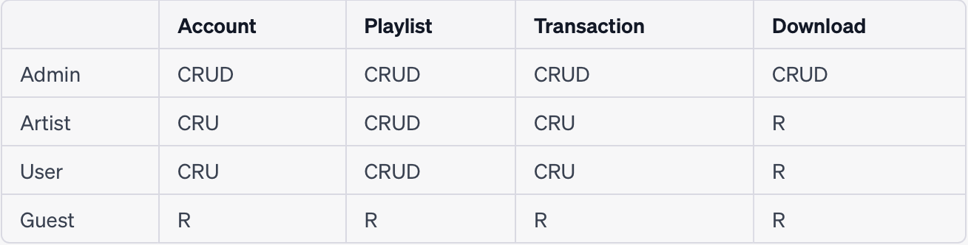

In this matrix, the rows represent different roles in the music streaming service, including Admin, Artist, User, and Guest. The columns represent specific activities or operations related to the CRUD (Create, Read, Update, Delete) functionality, such as managing the account, creating and managing playlists, performing transactions, and accessing downloads. The letters in each cell indicate the level of access and permission for each role and activity.

* Admin: The admin role has full access and permissions to perform all activities, including creating, reading, updating, and deleting accounts, playlists, transactions, and downloads (CRUD).
* Artist: Artists have permissions to create, read, and update their own account information (CRU). They can create, read, update, and delete their own playlists (CRUD). They can perform transactions related to their own content (CRU). However, they can only access and read downloads (R), not perform any other actions on them.
* User: Regular users can create, read, and update their own account information (CRU). They can create, read, update, and delete their own playlists (CRUD). They can perform transactions related to their own purchases (CRU). Similar to artists, users can only access and read downloads (R), not perform any other actions on them.
* Guest: Guests have read-only access to the account information (R), playlists (R), transactions (R), and downloads (R). They cannot perform any create, update, or delete actions.

# Master data standards

Master data standards for a streaming music service database refer to the guidelines and rules set for maintaining and managing consistent and accurate master data within the database. Master data typically includes core entities and attributes that are critical to the functioning of the streaming music service. Here are some key aspects of master data standards for a streaming music service database:

1. Entity Definitions: Clearly define the core entities in the database, such as artists, albums, tracks, playlists, genres, and users. Each entity should have a clear definition, including its purpose, scope, and attributes.
2. Data Integrity: Establish rules and standards to ensure data integrity. This includes defining data types, lengths, formats, and validation rules for each attribute. It helps maintain consistent and accurate data throughout the database.
3. Unique Identifiers: Define unique identifiers for key entities, such as artist IDs, album IDs, track IDs, and user IDs. These identifiers serve as primary keys and help establish relationships between different entities.
4. Naming Conventions: Establish naming conventions for entities and attributes to ensure consistency and readability. Consistent naming conventions improve the understanding and maintainability of the database schema.
5. Data Governance: Implement data governance practices to manage the lifecycle of master data. This includes defining roles and responsibilities for data stewardship, data quality monitoring, and data maintenance processes.
6. Standardized Codes and Classifications: Define standardized codes and classifications for attributes that require predefined values, such as genre classifications, country codes, language codes, and release types. Standardized codes promote consistency and enable easier data analysis and reporting.
7. Versioning and History: Consider incorporating versioning and history tracking for master data, especially for entities that undergo frequent updates or changes. This allows for tracking changes over time and maintaining historical records.
8. Data Integration and Interoperability: Ensure master data standards align with industry standards and protocols to facilitate data integration and interoperability with other systems, such as music licensing organizations, metadata providers, and external APIs.
9. Data Security and Privacy: Incorporate data security and privacy measures to protect sensitive master data, including user information, financial data, and intellectual property rights. Implement access controls, encryption, and data anonymization techniques as per applicable regulations and best practices.
10. Documentation and Data Dictionary: Maintain comprehensive documentation and a data dictionary that describes the structure, relationships, and attributes of the master data entities. This documentation aids in understanding the database schema and assists developers, analysts, and stakeholders in working with the data effectively.

# BI development

To create a multidimensional model for a BI solution, we use a star schema with a central fact table surrounded by dimension tables.

This multidimensional model allows for analysis and reporting across various dimensions. Users can explore data by slicing and dicing across dimensions like track, user, album, artist, genre, playlist, and subscription. Measures such as transaction amount can be aggregated and analyzed against different dimensions to gain insights into user preferences, popular tracks or albums, subscription trends, and more.

We use Power BI, a business analytics tool developed by Microsoft, offers several advantages for organizations:

1. User-Friendly Interface: Power BI provides an intuitive and user-friendly interface, making it accessible to both technical and non-technical users. The drag-and-drop functionality and visually appealing dashboards make it easy to create and customize reports and visualizations without extensive coding or programming knowledge.
2. Data Connectivity: Power BI offers a wide range of data connectors, allowing users to connect to various data sources, including databases, cloud services, spreadsheets, and APIs. This enables seamless integration of data from multiple sources into a single unified view for analysis and reporting.
3. Data Exploration and Visualization: Power BI offers powerful data exploration and visualization capabilities. Users can easily explore and analyze large volumes of data using interactive visualizations such as charts, graphs, maps, and tables. This helps in uncovering insights and patterns that might be hidden in the data.
4. Real-Time Data Analysis: Power BI supports real-time data analysis, enabling users to monitor and analyze data as it is being generated. This is particularly useful for tracking key performance indicators (KPIs) and making data-driven decisions in real-time.
5. Collaboration and Sharing: Power BI allows users to collaborate and share reports, dashboards, and datasets with colleagues and stakeholders. This promotes collaboration, facilitates data-driven discussions, and ensures that everyone is working with the same up-to-date information.
6. Mobile Accessibility: Power BI provides mobile applications for iOS and Android devices, allowing users to access and interact with reports and dashboards on the go. This enables decision-makers to stay informed and make data-driven decisions anytime and anywhere.
7. Integration with Microsoft Ecosystem: Power BI seamlessly integrates with other Microsoft tools and services such as Excel, SharePoint, Azure, and SQL Server. This enables easy data integration, sharing, and leveraging existing infrastructure and investments in the Microsoft ecosystem.
8. Advanced Analytics and AI Capabilities: Power BI offers advanced analytics capabilities, including predictive analytics, natural language processing, and machine learning. These features allow users to gain deeper insights from data and generate data-driven predictions and recommendations.
9. Scalability and Enterprise-Grade Security: Power BI is designed to scale from small teams to large enterprise deployments. It offers enterprise-grade security features, including role-based access control, data encryption, and compliance certifications, ensuring data privacy and security.
10. Community and Support: Power BI has a large and active user community. Microsoft provides comprehensive documentation, online forums, and support resources, making it easier to get assistance, share knowledge, and stay updated with the latest features and best practices.

Overall, Power BI provides a powerful and user-friendly platform for data visualization, analysis, and reporting. Its flexibility, connectivity, collaboration features, and integration capabilities make it a popular choice for organizations looking to leverage their data for better decision-making.

First of all, you need to configure the connection in Power BI itself, for this we enter the server that is generated from our link, as a result we get uk06734.europe-west4.gcp.snowflakecomputing.com. After that, we specify the name of the warehouse, in our case it is COMPUTE_WH, and then in the additional settings we specify the MUSIC_SERVICE_DATABASE database and the script that pulls up the necessary data for the report. This script is presented below.

|  |
| --- |
| **SELECT** T.TITLE,  A.NAME ARTIST,  AL.NAME ALBUM,  G.NAME GENRE,  T.DURATION  **FROM** MUSIC_SERVICE_DATABASE.MUSIC_SERVICE_SCHEMA.TRACK T  **LEFT JOIN** MUSIC_SERVICE_DATABASE.MUSIC_SERVICE_SCHEMA.ARTIST A  **ON** T.ARTISTID = A.ARTISTID  **LEFT JOIN** MUSIC_SERVICE_DATABASE.MUSIC_SERVICE_SCHEMA.ALBUM AL  **ON** AL.ALBUMID = T.ALBUMID  **LEFT JOIN** MUSIC_SERVICE_DATABASE.MUSIC_SERVICE_SCHEMA.GENRE G  **ON** G.GENREID = AL.GENREID |

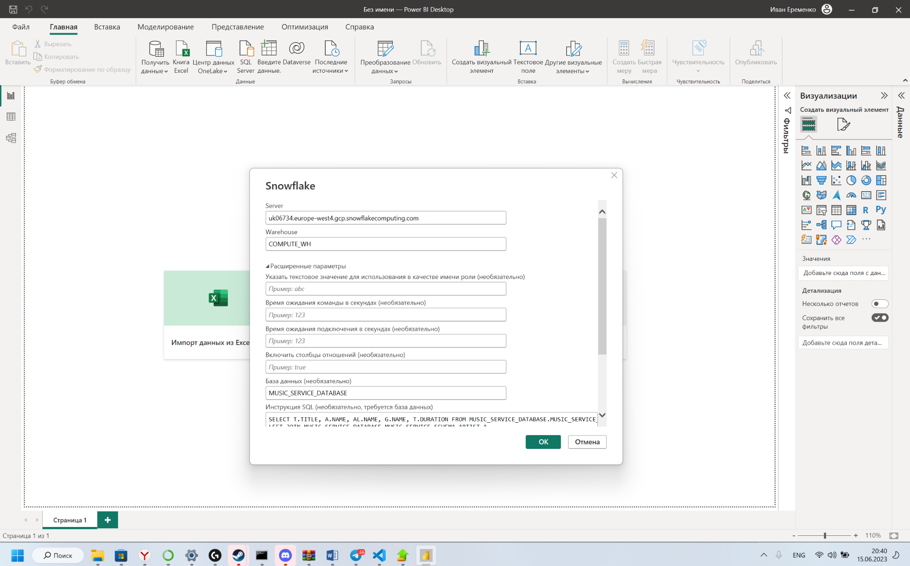

The first report that we created is a report on existing tracks in the Database. First, we created a histogram with a grouping on which you can see the total duration of tracks by genre. In addition, we have added a drill down function so that for each genre you can see which musicians release tracks on it and what their total duration is on the platform. After that, we added pie charts to see the distribution of tracks by genre, two such charts were added, one by the number of tracks and the second by the length of tracks.

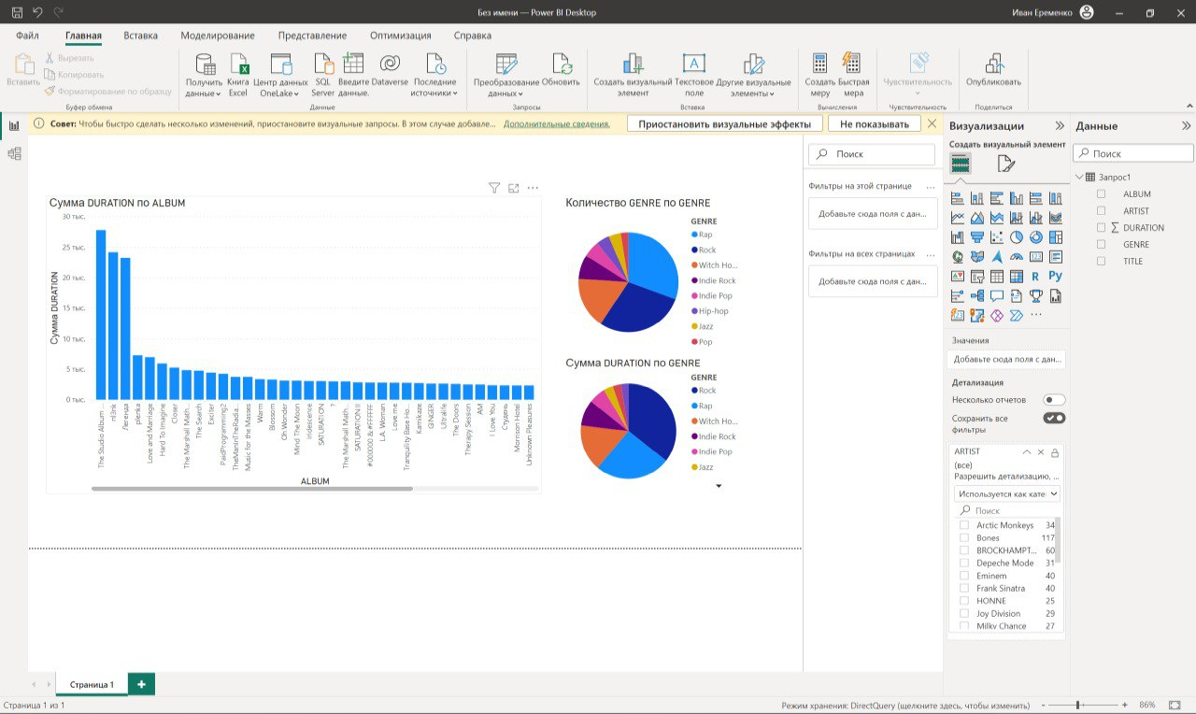

After that, we costamized the report, added a name to it, changed the signatures of all graphs and added an icon at the top.

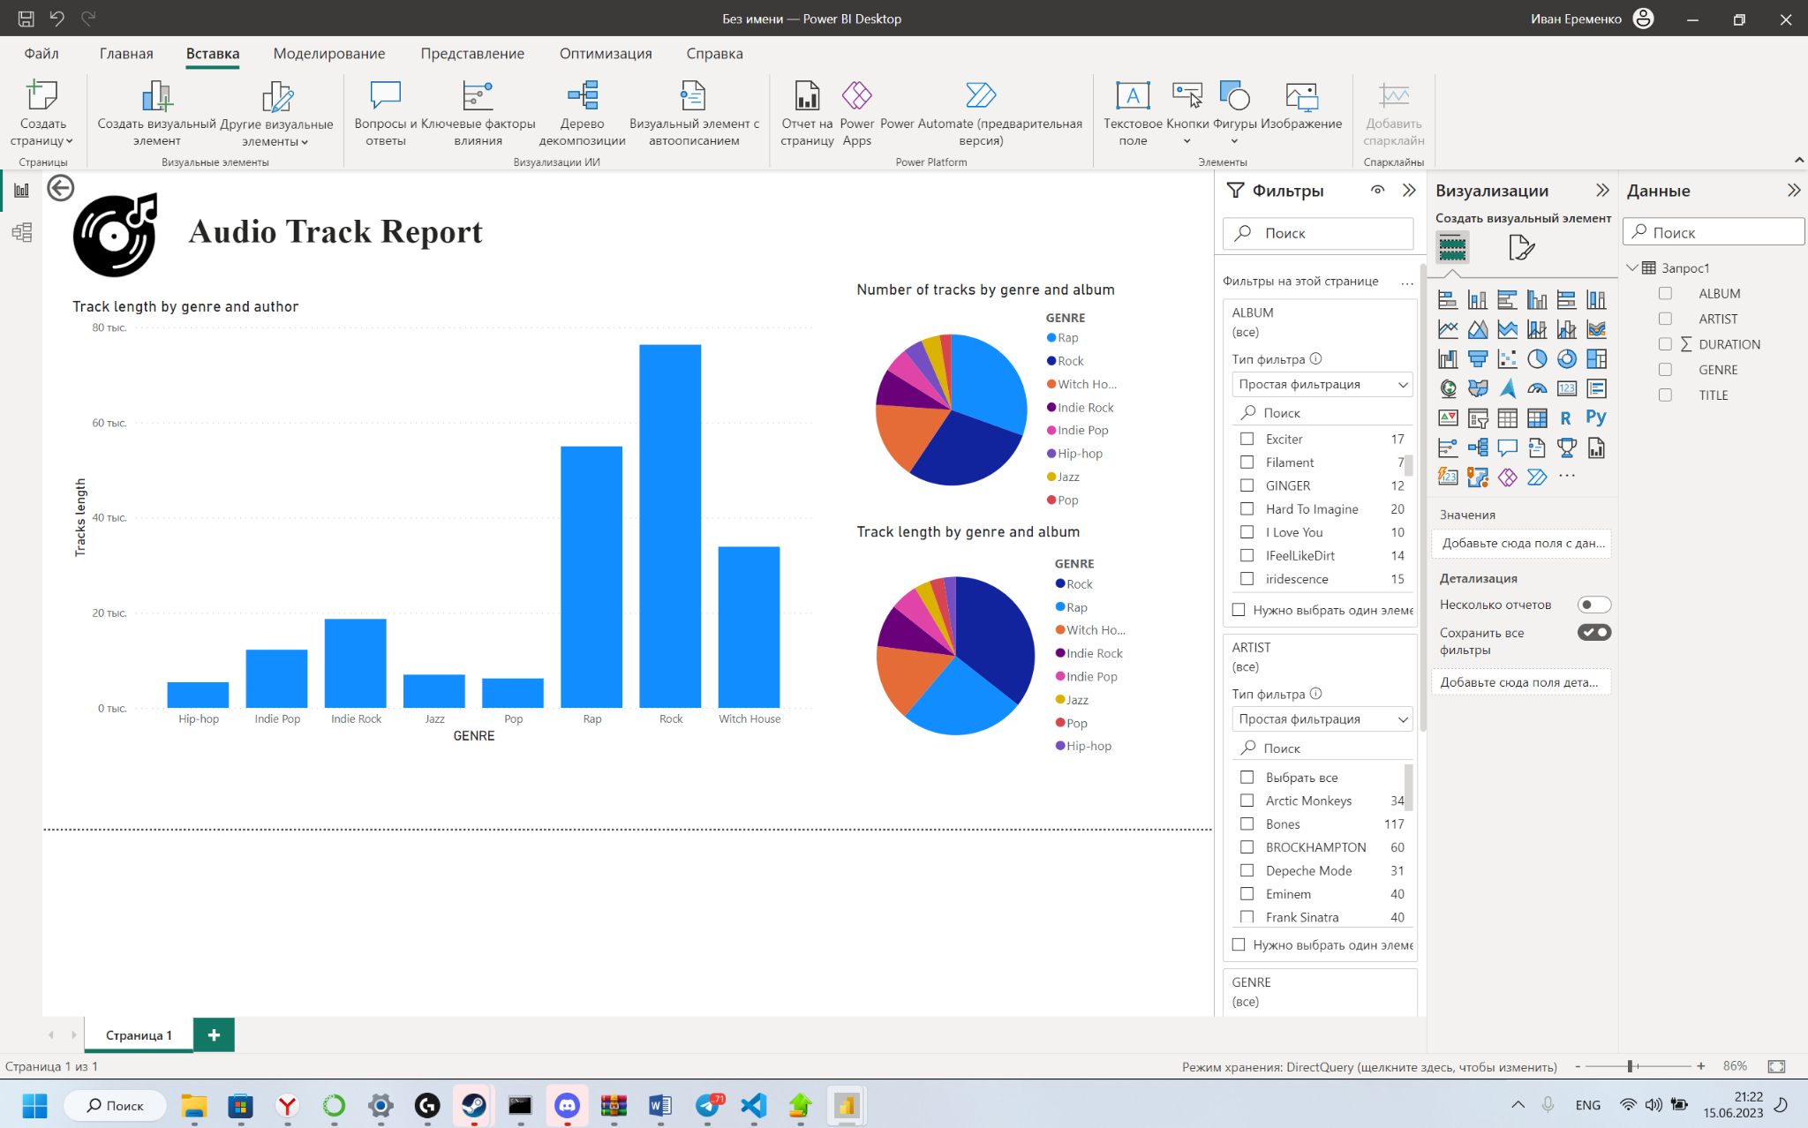

The final stage was uploading the report to the Power BI cloud and checking it for reading tables and presenting correct information.

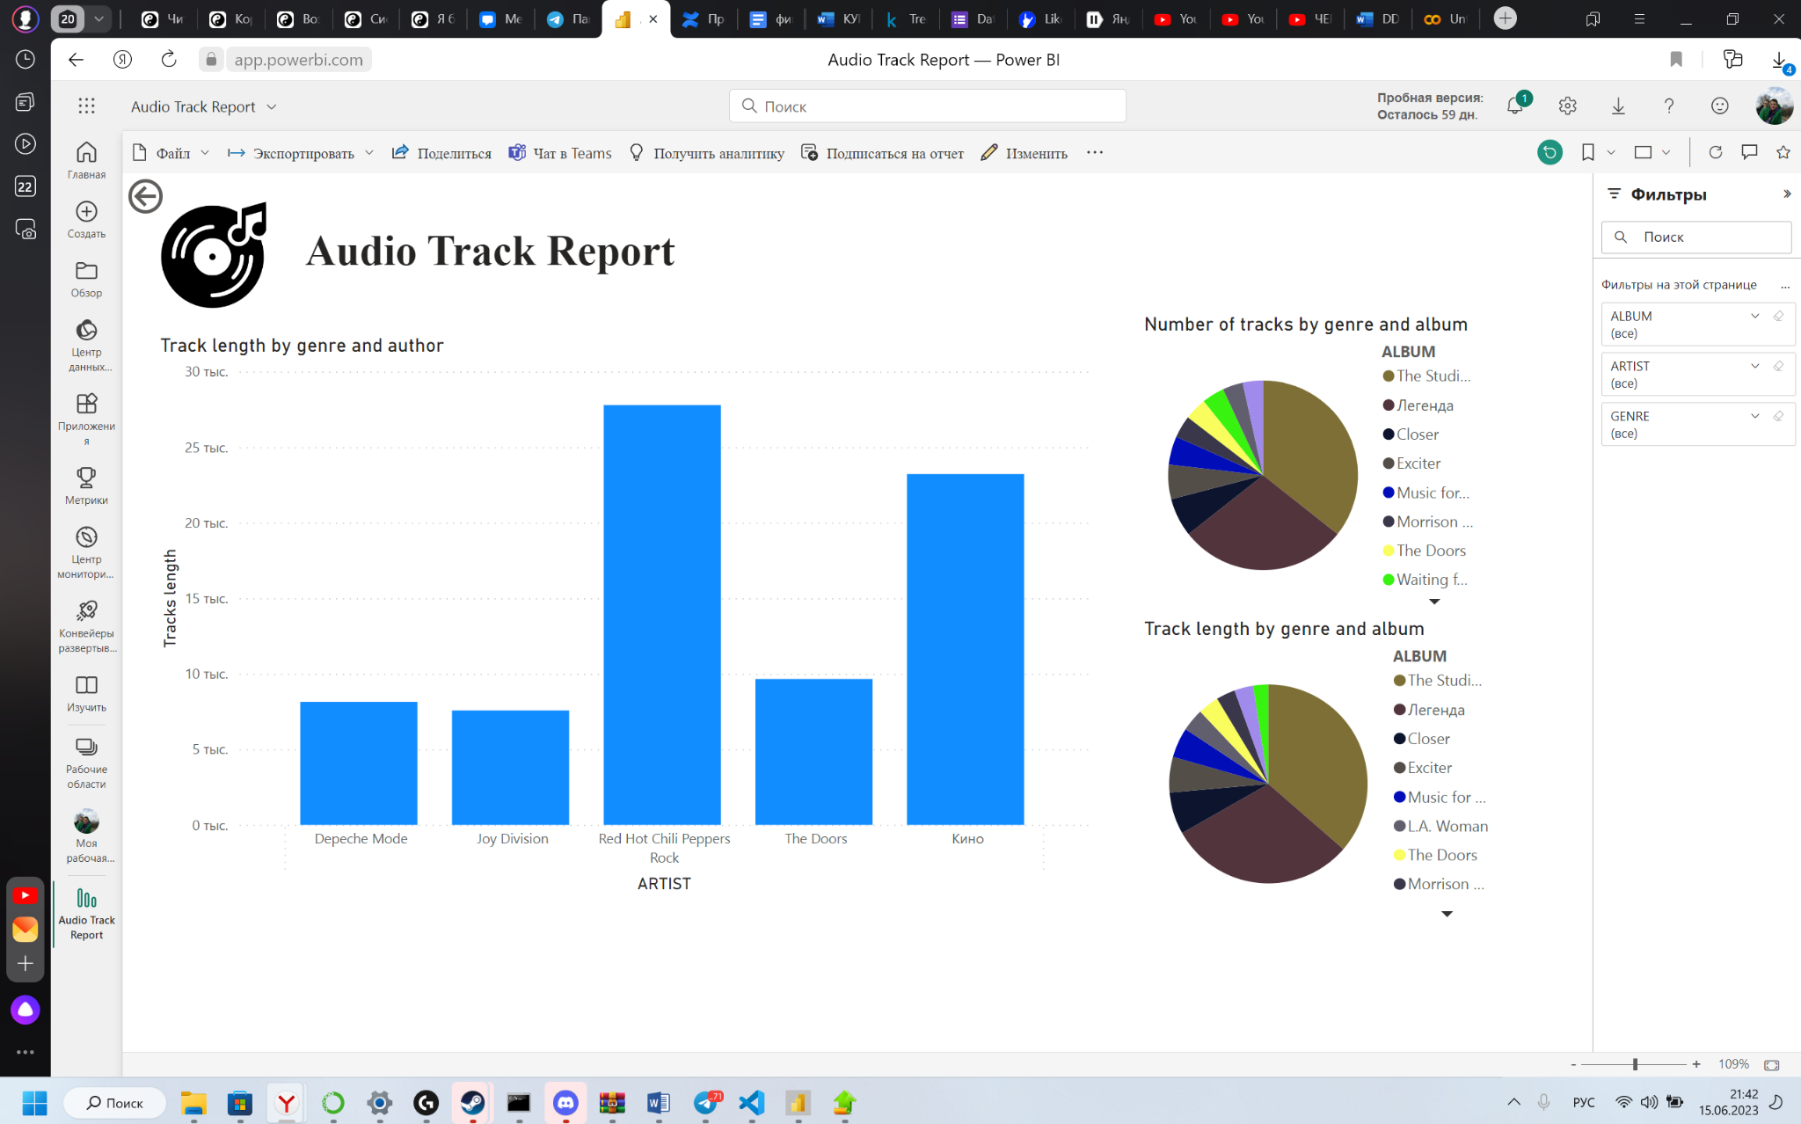

After that, we started creating a second report, it should show the income that the company received for the entire period. To begin with, we created a new connection in our database again, changing only the request of the request, it became the following.

|  |
| --- |
| **SELECT** us.name,  tran.transactionid,  tran.amount,  tran.datetime,  sub.startdate,  sub.enddate  **FROM** MUSIC_SERVICE_DATABASE.MUSIC_SERVICE_SCHEMA.SUBSCRIPTION sub  **LEFT JOIN** MUSIC_SERVICE_DATABASE.MUSIC_SERVICE_SCHEMA.USER us  **ON** sub.userid = us.userid  **LEFT JOIN** MUSIC_SERVICE_DATABASE.MUSIC_SERVICE_SCHEMA.TRANSACTION tran  **ON** sub.transactionid = tran.transactionid |

# After that, we created a histogram with a grouping in which we included the company's revenues grouped by date, the years are coming, but you can fall down and see the distribution by months in the year, we also added the ability to fall even lower and see the distribution by users.

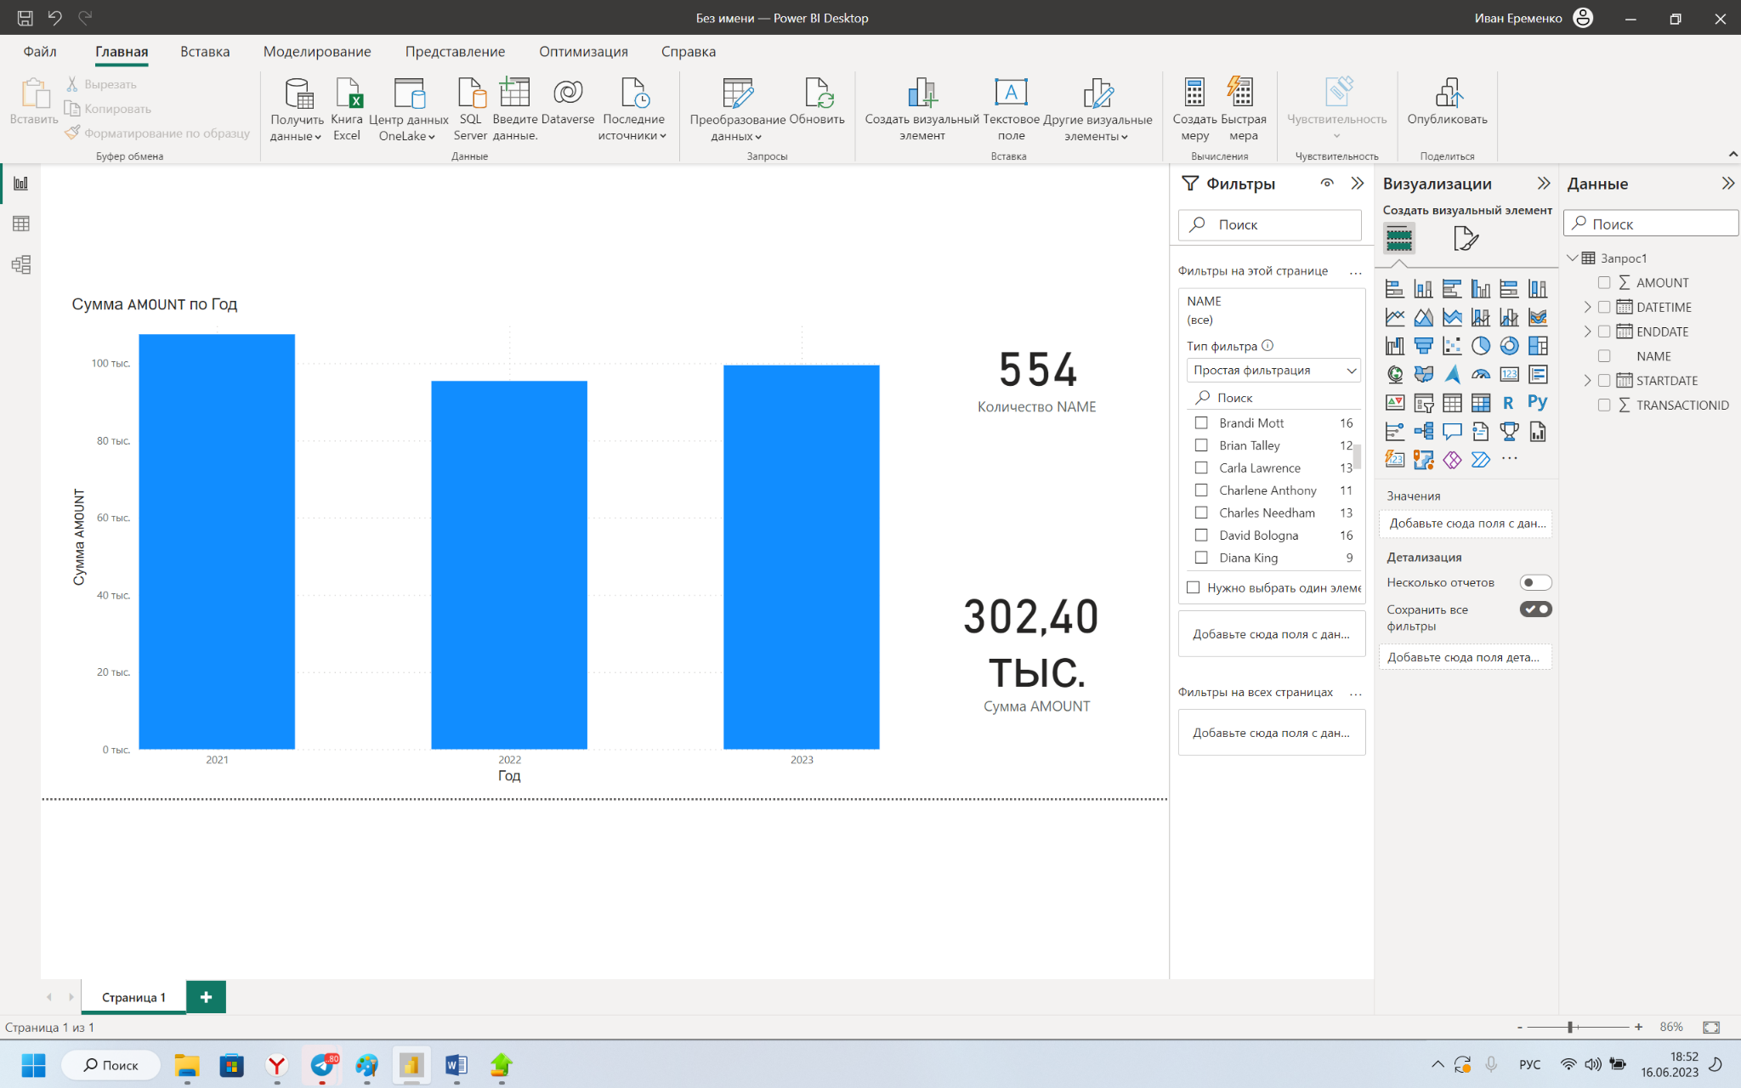

We have also added two test fields on the right, which display the amount of revenue and the number of transactions for the selected period. After that, we formatted all the charts, added the name to the chart and changed all the captions.

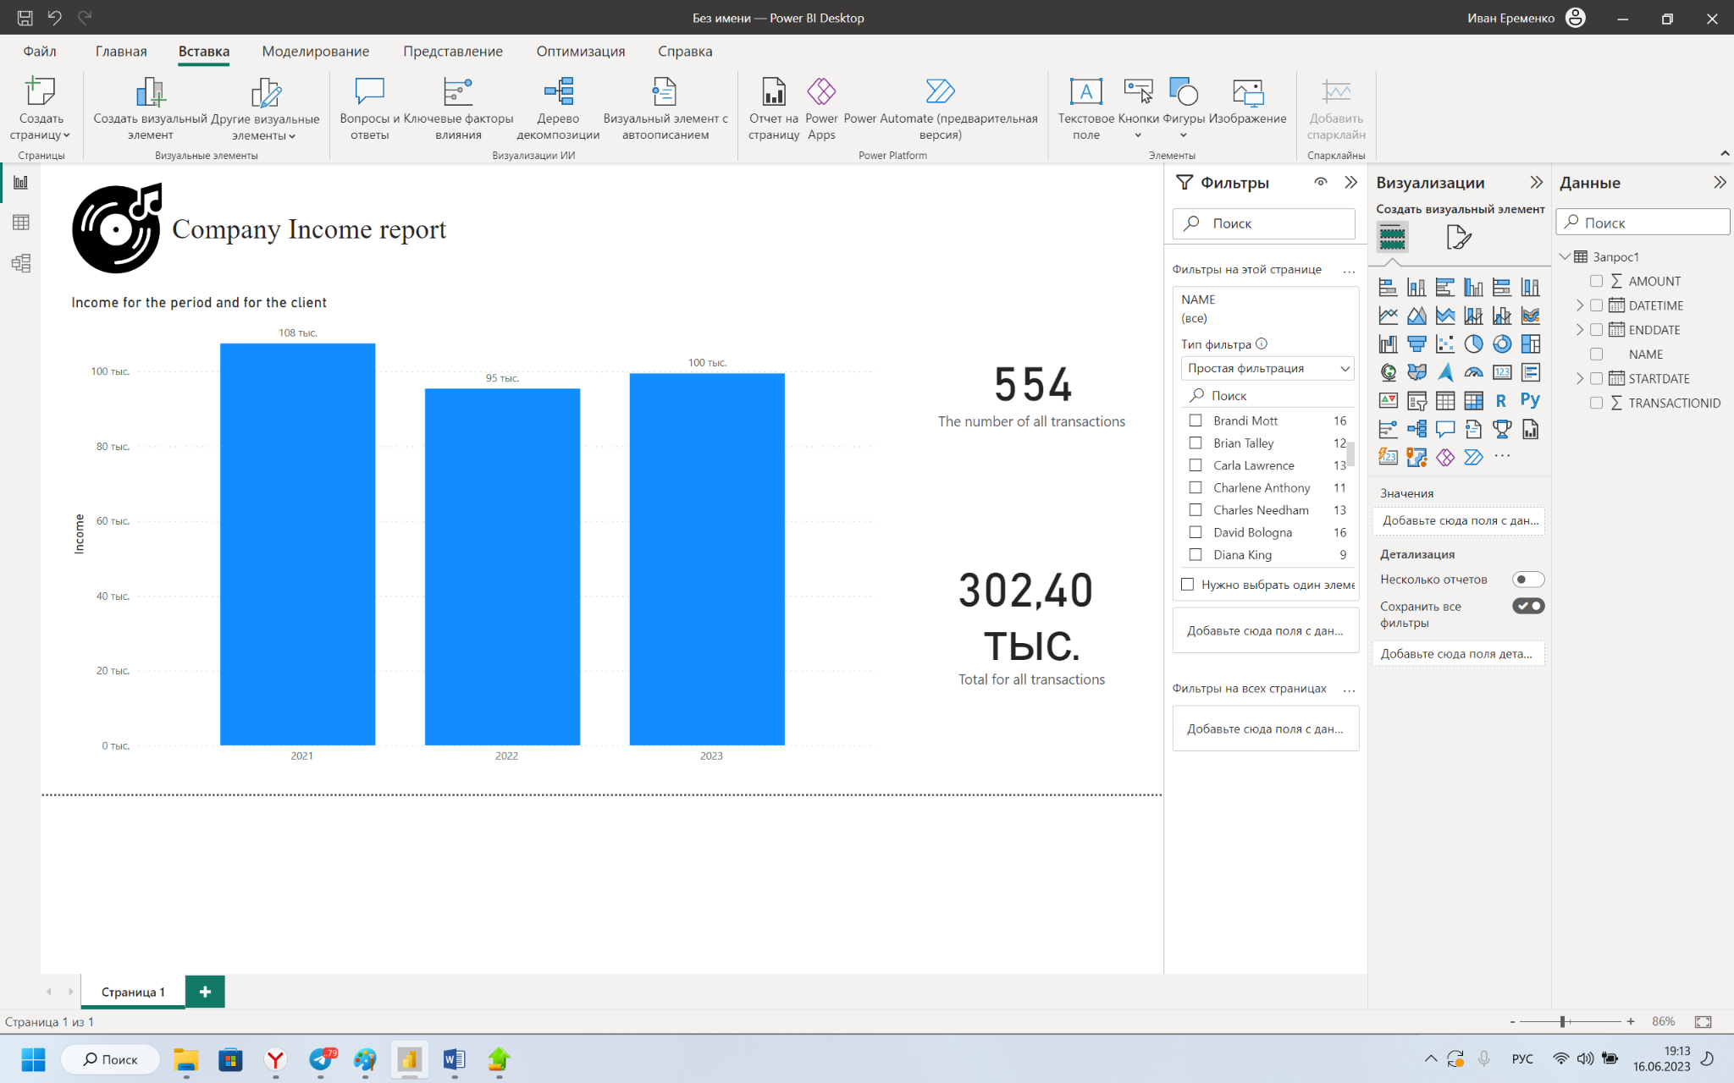

The final stage was uploading the report to the Power BI cloud and checking it for reading tables and presenting correct information.

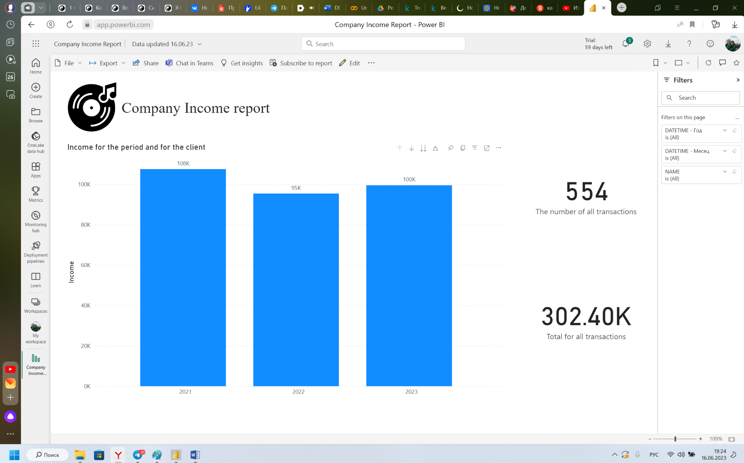

# Bibliography

1. "Music Streaming and Cloud-Based Services" by William Li and Jian Zhao
2. "Big Data Analytics for Music and Entertainment Industry" by Jayanthi Ranjan and Suman Bhattacharya
3. "Data Infrastructure Management: Insights and Emerging Trends" edited by Surya Nepal, Dinesh Garg, and Rajiv Ranjan
4. "Data-Intensive Text Processing with MapReduce" by Jimmy Lin and Chris Dyer
5. "Streaming, Sharing, Stealing: Big Data and the Future of Entertainment" by Michael D. Smith and Rahul Telang
6. "Data Science for Business: What You Need to Know about Data Mining and Data-Analytic Thinking" by Foster Provost and Tom Fawcett
7. "Data-Driven: Creating a Data Culture" by Hilary Mason and DJ Patil
8. "The Data Warehouse Toolkit: The Definitive Guide to Dimensional Modeling" by Ralph Kimball and Margy Ross
9. "Streaming Systems: The What, Where, When, and How of Large-Scale Data Processing" by Tyler Akidau, Slava Chernyak, and Reuven Lax